

**Debre Berhan University**

**College of Computing**

**Department of Information Systems**

**Internship Report**

**Project Title**: GET Crop Information Tool

**Hosting Company**: KUKUNET Digital

**Internee**: Selamawit Girma DBU1501458

Hana Shewareged DBU1501644

Hana Solomon DBU1501252

**Mentors:** Seblewengel Esseynew (Ph.D) and Yordanos F.

**Company Supervisor**: Solomon Abate (Ph.D)

**November, 2025**

**KUKUNET Digital,**

**Gurd Shola, Ministry of Agriculture Bldg**

**Declaration**

We, the undersigned, declare that the internship report entitled *“Get Crop Info Tool”* has been prepared solely as part of our academic requirements for the degree of **B.Sc. in Information Systems** at **Debre Berhan University**. This report is our own work and has not been submitted to any other institution for any academic award. All sources of information used in the preparation of this report have been duly acknowledged.

| Name | Signature | Date |
| --- | --- | --- |
| Selamawit Girma | _________________________ | ________ |
| Hana Shewareged | _________________________ | ________ |
| Hana Solomon | _________________________ | ________ |

**Acknowledgements**

First and foremost, we would like to express our sincere gratitude to our internship supervisor, **Solomon Abate (Ph.D.)**, for his invaluable guidance, unwavering support, and continuous encouragement throughout the internship period.

We also extend our heartfelt thanks to the entire team at **KUKUNET Digital** for providing us with the opportunity to work on the *Get Crop Info Tool* project. Their mentorship and cooperation made this a highly rewarding professional experience.

Our appreciation goes to **Debre Berhan University** for equipping us with the foundational knowledge and skills necessary to undertake this internship successfully.

Finally, we would like to thank our families and friends for their unwavering moral support and motivation throughout this journey.

Thank you all.

**Executive Summary**

This internship report details the design, development, and implementation of the *Get Crop Info Tool,* a software application developed to provide farmers and agricultural stakeholders with accurate and timely crop information. The project was undertaken at **KUKUNET Digital** to fulfill the academic requirements for the [**B.Sc**](https://b.sc/)**. in Information Systems at Debre Berhan University.**

The report begins by outlining the company background, including its history, core products, technological stack, and organizational structure. It then describes the internship experience, documenting the tasks performed, methodologies and tools applied, challenges encountered, and professional skills acquired.

A central focus of the report is the project work, which involved analyzing existing systems, identifying their limitations, and developing a user-friendly solution to bridge the information gap. The development process adhered to modern software engineering best practices and utilized contemporary frameworks.

The results demonstrate that the tool successfully enhances agricultural decision-making by delivering reliable crop data, thereby contributing to improved productivity. The report concludes with recommendations for future enhancements and personal reflections on the overall internship experience.

Contents

1. KUKUNET Digital: Corporate Profile 1

1.1. About company 1

1.2. Main Products, Services and Technologies of the Company 1

1.2.1. Services 1

1.2.2. Products 2

1.2.3. Technologies 4

1.3. Main Customers and End Users 4

1.3.1. Main Customers (Who Pays for the Service) 4

1.3.2. End Users (Who Actually Uses the Products Daily) 5

1.4. Organizational structure 5

1.5. Company Workflow Overview 7

2. Internship experience 9

*2.1.* *In which section/department of the company you have been working and why?* 9

*2.2.* *Which workpiece or work tasks you have been executing?* 9

*2.3.* *What types of System Development, tools and techniques you have been using while performing your work tasks* 11

2.3.1. System Development Methodology: 11

2.3.2. Tools & Technologies: 11

2.3.3. Techniques & Approaches: 12

*2.4.* *What major challenges and problems you have been facing and identifying while performing your work tasks?* 13

*2.5.* *What measures you have taken? (propose as a solution for the selected problems) in order to overcome these challenges and problems, etc.* 13

*2.6.* *What you have got in terms of improving your practical skills* 14

*2.7.* *What you gained in terms of upgrading your theoretical knowledge?* 15

*2.8.* *What you gained in terms of improving your team playing skills?* 15

*2.9.* *What you gained in terms of improving your leadership skills?* 16

*2.10.* *What you gained in terms of understanding work ethics issues, company psychology, and related issues?* 17

*2.11.* *What you gained in terms of entrepreneurship skills?* 18

*2.12.* *What you gained in terms of improving your interpersonal communication skills?* 18

*2.13.* *Recommendation and conclusion on your internship?* 19

2.13.1. Conclusion: 19

2.13.2. Recommendations: 20

3. Design and Development of a Get Crop Info Tool: A Web-Based Solution for the Ethiopian Ministry of Agriculture 21

3.1. project Summary 21

3.1.1. Overview 21

3.1.2. Technical Implementation 21

3.1.3. Core Features 22

3.1.4. User Experience 23

3.2. Problem Statement 24

3.3. Justification for GET Crop Info Tool 24

3.4. Comparative Advantage Over Existing Solutions 26

3.5. Objective of the project 27

3.5.1. General Objective 27

3.5.2. Specific Objectives 27

3.6. Methodology for GET Crop Info Tool 28

3.6.1. Key fact-finding techniques 28

3.6.2. Tools, Languages, Frameworks & Network Topology 29

3.6.3. Design Used 32

3.7. Results and Discussion 33

3.7.1. Results 33

3.7.2. Discussion 34

3.8. Screenshot Sections with Interactive Elements for GET Crop Info tool 36

3.8.1. Section 1: Welcome & Language Selection 36

3.8.2. Section 2: User part 37

3.8.3. Section 3: Download Option/Offline Accessibility 38

3.8.4. Section 4: The Humberger part 38

3.8.5. Section 5: Crop Information 42

3.8.6. Section 6: Chatbot 43

3.8.7. Section 7: Footer Part 44

3.8.8. Section 8: Admin login 44

3.8.9. Section 9: Admin Dashboard 45

3.9. Conclusion and recommendation 48

3.9.1. Conclusion 48

3.9.2. Recommendations for Future Enhancement 49

4. General Conclusion and Recommendation 51

4.1. General Conclusion 51

4.2. General Recommendation 52

4.2.1. For KUKUNET Digital: 52

4.2.2. For Debre Berhan University: 52

4.3. References 52

4.4. Appendices 53

List of Tables

Table 1: Tools and Technologies that are Used to Perform Internship Tasks 12

Table 2: Tools that are Used for GET Crop Info Tool 30

Table 3: Languages that are Used for GET Crop Info Tool 30

Table 4: Frameworks and Libraries that are Used for GET Crop Info Tool 31

List of Figures

Figure 1: Network Topology Architecture 31

Figure 2: Welcome Page 36

Figure 3: First User Interface Part 37

Figure 4: Download Option 38

Figure 5: Humberger 38

Figure 6: Feedback 39

Figure 7: Recommendation 40

Figure 8: About us 41

Figure 9: Graph 41

Figure 10: Detail Information about Crops 43

Figure 11: Chatbot 44

Figure 12: Contact Information 44

Figure 13: Admin Login 45

Figure 14: Dashboard 46

Figure 15: Edit and Delete Existing Crops 46

Figure 16: Adding New Crop Information Sheets 47

Figure 17: Managing User Feedback 48

# **KUKUNET Digital: Corporate Profile**

## **About company**

KUKUNET digital is a private limited company founded in 2020 in Addis Ababa, Ethiopia. The company was established by a team of four founding members with strong educational backgrounds in software development. From the beginning, the company has prioritized a commitment to both expertise and diversity, with its team of eight members being equally split between four female and four male staff. In its first few years, it has already developed an impressive portfolio of digital systems, primarily for governmental and agricultural sectors, and has received formal recognition from the Ethiopian Ministry of Agriculture for its contributions**.**

## **Main Products, Services and Technologies of the Company**

### **Services**

* **Custom Software Development**
  + Building tailored digital solutions to address specific client challenges and objectives.
* **IT Consultancy & Strategic Guidance**
  + Advising businesses on digital transformation, process optimization, and technology adoption.
* **Technical Training Programs**
  + **Corporate Training:**Ensuring client staff can effectively use newlyimplemented systems.
  + **Youth Outreach:**Short-term coding training programs for children.

### **Products**

They are custom-built digital systems and solutions developed for specific clients and purposes. These projects showcase their expertise across various sectors.

Here is a classification of their main products:

1. **Agricultural Management & Tracking Systems**

This is a clear specialty area, with many projects developed for the Ministry of Agriculture.

* **ATIS (Agricultural Technology Information System):** Provides farmers with crucial data on seeds, soil, and fertilizers.
* **National Fertilizer Supply Tracking System:** Offers real-time insights and control for optimizing fertilizer use across the country.
* **Horticulture Investment Tracking System:** A detailed national database for tracking horticulture farm investments.
* **Live stock investment Information Management System:** Dedicated to managing and tracking livestock investments nationwide.
* **Large Scale Agricultural Investment System:** Manages data and provides insights on major agricultural investments.

1. **Research & Institutional Management Systems**

Designed for universities, research centers, and government bodies to streamline complex processes.

* **Research Management System (RMS):**A customized system for managing data collection, analysis, and other research processes.
* **Laboratory Information Management System (LIMS):**Manages all laboratory activities, including inventory, equipment maintenance, and sample tracking**.**
* **Performance Measurement System (PMS):**Evaluates and monitors employee performance, particularly for researchers.
* **Publication Management System (KPUMS):**Converts and manages scientific and non-scientific publications.
* **Marker Assisted Breeding Platform:**A platform for researchers to register profiles and publish their work, facilitating collaboration**.**

1. **Public Service & Governance Systems**

**Solutions that digitize government and civic functions.**

* **Patent Registration System (PRS):**Allows patent holders to register and certify patents online without a physical presence.
* **Digital Letter Management System**: Manages and tracks official correspondence for efficient and secure communication.
* **Enhanced Planning and Reporting Digital System:**Revolutionizes activity planning and reporting with real-time insights and analytics.

1. **General Enterprise & Business Solutions**

Versatile systems applicable to a wide range of businesses and organizations (Government, NGO, and Private Sector).

* **Digital Attendance System (DAS**): Controls employee timetables using only their cell phones, no external hardware required.
* **Fleet Management System (FMS):**Controls driver activities, vehicle conditions, and records all legal vehicle information.
* **Archives Management System (AMS):**Enables digital record-keeping and registration of documents, eliminating printing.
* **Report Management System (RMS**): Provides a systematic and uniform way of reporting for organizations.
* **Events Management System (EMS):**Provides full assistance for managing training sessions, conferences, and workshops.
* **Online Appointment System:**A platform for efficiently scheduling and managing appointments.
* **MESOB AF&B Management System:**A digital ordering system for Hotels, Cafés, and Restaurants.
* **To-Do List Application:**A tool designed to help experts organize and prioritize tasks effectively.

### **Technologies**

Technology-related inferences that are made by the company are:

* **Mobile Technology:** The Digital Attendance System (DAS) is described as needing "no external device but cell phones of employees only," indicating they develop applications that run on standard smartphones (iOS/Android).
* **Web Technology:** The nature of the products (management systems, registration systems) strongly implies they are web-based applications.
* **General HW/SW:** The services require computers and servers for development, testing, and deployment, but no specific brands or models are mentioned.

## **Main Customers and End Users**

### **Main Customers (Who Pays for the Service)**

These can be summarized into three main customer segments:

* **Governmental Institutions:** This is their largest and most prominent customer segment.
  + **Ministry of Agriculture:** Featured as the primary client for multiple agricultural systems.
  + **Ethiopian Intellectual Property Authority:** Client for the Patent Registration System (PRS).
  + Various other government bodies and public institutions.
* **Non-Governmental Organizations (NGOs):** Specifically those involved in supporting agriculture, farming, and development.
* **Private Sector Companies:** This includes a range of businesses.
  + Research Centers (both private and public)
  + Higher Education Institutions (Universities, Colleges)
  + Hotels, Cafés, and Restaurants (Client for the MESOB AF&B system)
  + Other Private Businesses across various sectors.

### **End Users (Who Actually Uses the Products Daily)**

The end-users are the people within those organizations who use the systems daily.

* **Farmers** (using systems like ATIS for agricultural information)
* **Researchers & Scientists** (using RMS, LIMS, PMS, Marker Assisted Breading platform)
* **Administrators & Managers** (across all sectors, using systems for reporting, archives, fleet management, etc.)
* **Employees** (using the Digital Attendance System - DAS)
* **Patent Holders & Intellectual Property Staff** (using the Patent Registration System - PRS)
* **Restaurant Staff and Customers** (using the MESOB AF&B ordering system.

## **Organizational structure**

**General Assembly**

* This is the highest governing body of the private limited company**.**

**Executive Leadership**

* **CEO**: Oversees the entire company.
* **Legal Advisor**: Provides legal counsel, reporting directly to the CEO.

**Department Heads (Reporting to the CEO)**

* **CTO (Chief Technology Officer):**Leads all technical development.
* **Finance and Admin Manager**: Leads financial and administrative operations.
* **Project Manager:**Oversees project execution and delivery.
* **Marketing and Sales Manager:**Leads client acquisition and business development.

**Teams and Staff (Reporting to Department Heads)**

* **Under Finance and Admin Manager:**
  + Accountant
  + Cashier
* **Under CTO:**
  + **Lead Developer (1)**
    - Front End Developers (2)
    - Back End Developers (2)
    - Full Stack Developers (2)
    - Mobile Developers (2)
    - API Developers (2)
  + **Lead Designer**
    - UX/UI Designers (2)
    - Graphics Designers (2)
    - Product Designer (1)
  + **LEAD QA (Quality Assurance)**
    - Web Tester
    - Mobile Tester
* **Under Marketing and Sales Manager:**
  + Sales Team Leader
    - Sales people

## **Company Workflow Overview**

**Sales & Client Onboarding**

* **Lead Generation:** The Marketing and Sales Manager and team promote services to government entities, NGOs, and private sector organizations.
* **Requirement Gathering**: Sales and technical staff (e.g., Lead Developer or Project Manager) engage clients to understand needs.
* **Proposal Submission:** A customized proposal is developed and submitted to the client.

**Project Planning & Resource Allocation**

* **Project Kickoff**: The Project Manager coordinates with the CEO and CTO to define scope, timelines, and deliverables.
* **Team Assembly:** The CTO assigns resources from development, design, and QA teams based on project requirements.
* **Tool Setup**: Use of project management and version control tools (e.g., Git, Jira — inferred from industry standards).

**Development & Design**

* **Design Phase:** The Lead Designer and team (UX/UI, Graphics) create wireframes, mockups, and user flows.
* **Development Phase:**
  + Back-End Team sets up databases, APIs, and server logic.
  + Front-End Team builds the user interface.
  + Mobile Team develops cross-platform or native apps if needed.
* **API Integration:**API Developers ensure seamless communication between front-end and back-end systems.

**Quality Assurance & Testing**

* **Testing Phase:** The LEAD QA oversees:
  + Web Tester: Tests web applications.
  + Mobile Tester: Tests mobile apps.
  + Feedback is looped back to developers for fixes.

**Deployment & Client Training**

* **Deployment**: The system is deployed to client’s environment (cloud or on-premise).
* **Training**: The Training team (under consultancy/services) conducts user training for the client’s staff.
* **Handover:** Project documentation and access are transferred to the client.

**Support & Maintenance**

* **Post-Launch Support**: The team provides ongoing maintenance and troubleshooting.
* **Feedback Incorporation:** Further refinements are made based on client feedback.

**Consultancy & Strategy**

* **Advisory Services:** The consultancy team provides strategic advice for digital transformation, often overlapping with ongoing projects.

# **Internship experience**

## *In which section/department of the company you have been working and why?*

We have been placed within the Information Technology and Digital Solutions department at KUKUNET Digital, under the direct supervision of Dr. Solomon Abate.

our primary focus has been on supporting the company's partnership with the Ethiopian Ministry of Agriculture, specifically within its Investment Sector. Our work involves a dual role:

* **Web Development & Project Work:** we are developing the *Get Crop Info Tool*, a web-based application designed to provide farmers and ministry staff with accessible agricultural information. This utilizes my technical skills in HTML, CSS, JavaScript, Node.js, and MongoDB.
* **Digital Media & Content Management:** we are responsible for media monitoring, which involves gathering, verifying, and preparing investment-related data and news from social media platforms for official publication on the Ministry's portals. We developed and maintained a detailed Microsoft Excel database to systematically track and analyze investment department desks, which involved gathering, validating, and synthesizing critical information to support data-driven decision-making and enhance operational efficiency within the department.

## *Which workpiece or work tasks you have been executing?*

During our internship, we have been executing a range of tasks that blend technical development, data management, and strategic communication. These can be categorized as follows:

**Web Application Development (*Get Crop Info Tool*)**

* **Frontend Development:** Designing and building the user interface (UI) using HTML, CSS, and JavaScript to ensure an intuitive experience for farmers and ministry staff.
* **Backend Development:** Setting up the server environment using Node.js, creating APIs, and integrating the application with a MongoDB database to store and retrieve crop-related data efficiently.
* **Full-Stack Integration:** Connecting the frontend and backend to enable dynamic data display and user interactions.

**Data Management & Analysis**

* **Media Monitoring:** Collecting, verifying, and preparing agricultural investment-related content from social media platforms (Facebook, YouTube).
* **Data Curation:** Organizing this information into structured formats (Excel, JSON) for reporting and database integration.
* **Quality Assurance:** Collaborating with investment staff to filter and validate data relevance and accuracy before publication.

**Reporting and Communication**

* **Weekly Reporting:** Documenting progress, challenges, and outcomes in detailed weekly reports submitted to both university and industry advisors.
* **Stakeholder Presentations:** Preparing and delivering updates via Zoom and in-person meetings on project milestones, technical approaches, and findings.

**Professional Development**

* **Skill Enhancement:** Practicing speed typing to improve efficiency and undertaking self-directed learning on relevant technologies (e.g., Node.js, MongoDB).
* **Process Improvement:** Developing checklists and frameworks to standardize workflows for data handling and project development.

## *What types of System Development, tools and techniques you have been using while performing your work tasks*

During our internship, we employed a modern, industry-standard tech stack and agile methodologies to develop the Get Crop Info Tool and support the Ministry of Agriculture’s digitization initiatives. Below is a detailed breakdown:

### **System Development Methodology:**

* **Agile Framework:**
  + Worked in 2-week sprints with iterative development, daily stand-ups (where applicable), and feedback loops.
  + Used Trello for task tracking and prioritization, ensuring alignment with project goals.

### **Tools & Technologies:**

| Category | Tools/Technologies Used | Purpose |
| --- | --- | --- |
| Frontend | React.js, HTML5, CSS, JavaScript | Built dynamic, responsive user interfaces for farmers and ministry staff. |
| Backend | Node.js, Express.js | Developed RESTful APIs for CRUD operations and business logic. |
| Database | MongoDB, Mongoose ODM | Managed structured and unstructured agricultural data efficiently. |
| Version Control | Git, GitHub | Collaborated on code, tracked changes, and managed project history. |
| API Testing | Postman, Thunder Client (VS Code) | Tested API endpoints for reliability, performance, and security. |
| Documentation | Markdown, Microsoft Word, Google Docs | Created technical docs, user manuals, and project reports. |
| Deployment | Netlify (Frontend), Render/Heroku (Backend), MongoDB Atlas | Deployed and hosted the application securely in the cloud. |

**Table 1: Tools and Technologies that are Used to Perform Internship Tasks**

### **Techniques & Approaches:**

* **Modular Development:**
  + Designed the system with reusable components (frontend) and middleware (backend) for scalability.
* **RESTful API Design:**
  + Created endpoints like GET /api/crops and POST /api/feedback to ensure seamless frontend-backend communication.
* **User-Centered Design (UCD):**
  + Conducted informal usability tests with ministry staff to refine UI/UX, especially for non-technical users.
* **Data Modeling:**
  + Used MongoDB’s flexible schema to store diverse crop data (e.g., varieties, seasons, pests) and user feedback.

## *What major challenges and problems you have been facing and identifying while performing your work tasks?*

**Technical Integration:**

* + Connecting MongoDB to Node.js backend efficiently.

**Data Quality & Standardization:**

* + Verifying accuracy of social media-sourced data.
  + Standardizing formats (Excel) for ministry use.

**Skill Gaps:**

* Rapid learning curve for Node.js, MongoDB,

## *What measures you have taken? (propose as a solution for the selected problems) in order to overcome these challenges and problems, etc.*

To address the challenges encountered during our internship, we implemented the following practical solutions:

**For Technical Integration Issues:**

* **Modular Development:** Broke down the backend (Node.js/Express) and database (MongoDB) integration into smaller, testable components. Used Mongoose for structured schema design and validation.

**For Data Quality & Standardization:**

* **Validation Protocols:** Created a checklist to verify social media-sourced data against official Ministry announcements before processing.
* **Template-Based Processing:** Developed standardized Excel/JSON templates with predefined fields (e.g., date, source, topic) to ensure consistency in curated data.

**For Skill Gaps:**

* **Targeted Learning:** Used YouTube tutorials (e.g., “Node.js MVC Structure,” “MongoDB Aggregation”) and practiced coding daily to strengthen backend skills.
* **Code Reviews:** Shared snippets of my code with senior developers for feedback on efficiency and best practices.

## *What you have got in terms of improving your practical skills*

Our internship at *KUKUNET Digital* significantly enhanced our practical skills in the following areas:

**Full-Stack Development:**

* **Frontend:** Improved proficiency in **HTML5**, **CSS**, and **JavaScript** while building responsive and interactive UIs for the *Get Crop Info Tool.*
* **Backend:** Gained hands-on experience in **Node.js**.
* **Database Management:** Mastered **MongoDB** (NoSQL) for data modeling, querying, and integration with backend systems.

**Data Processing & Analysis:**

* **Excel Advanced Features:** Used **conditional formatting, filtering, and graphs** to analyze and visualize agricultural investment data.
* **Data Validation:** Developed protocols to clean, verify, and standardize data from social media and ministry sources.
* **Development Tools:** Enhanced efficiency with **VS Code** and **MongoDB Compass**

**Problem-Solving & Adaptability:**

* **Debugging:** Developed systematic approaches to troubleshoot code errors and integration issues.
* **Flexibility:** Adapted to changing project requirements and balanced multiple responsibilities (development + data curation).

**Professional Growth:**

* **Time Management:** Prioritized tasks effectively to deliver results under deadlines.
* **Documentation:** Created clear technical and process documentation for future reference.

## *What you gained in terms of upgrading your theoretical knowledge?*

Throughout our internship, we significantly upgraded our theoretical knowledge by bridging academic concepts with real-world applications. We gained a deeper understanding of software architecture principles. Our work with MongoDB advanced our knowledge of non-relational database design, highlighting the trade-offs between flexibility and normalization. Theories of user-centered design and usability heuristics informed my approach to creating intuitive interfaces, while agile methodology principles shaped our project management and iteration processes. Additionally, we strengthened our grasp of data ethics, stakeholder management, and client-server communication models. This experience transformed abstract theories into tangible insights, enhancing my ability to design, develop, and manage technology solutions effectively.

## *What you gained in terms of improving your team playing skills?*

During our internship, we significantly enhanced our teamwork abilities through practical collaboration and communication in a professional environment. Specifically, we learned to:

* **Coordinate Effectively with Cross-Functional Teams:**
  + Collaborated with backend developers, data curators, and ministry staff to align goals, share progress, and integrate feedback into the *Get Crop Info Tool.*
* **Communicate Clearly and Professionally:**
  + Practiced expressing technical ideas (e.g., API requirements, UI suggestions) to both technical and non-technical stakeholders, ensuring everyone remained informed and engaged.
* **Give and Receive Constructive Feedback:**
  + Participated in code reviews and project discussions where we learned to incorporate suggestions gracefully and provide thoughtful input to peers.
* **Adapt to Team Workflows and Tools:**
  + Used collaborative tools like Git/GitHub for version control, Trello for task tracking, and Slack for daily communication, ensuring seamless coordination.
* **Support Team Goals Over Individual Tasks:**
  + Balanced our responsibilities between development and media monitoring to help the team meet collective deadlines and objectives.
* **Resolve Conflicts Proactively:**
  + Navigated differences in opinion related to project design or data handling by focusing on shared goals and evidence-based discussions.

## *What you gained in terms of improving your leadership skills?*

While our role was primarily as an intern, we proactively developed foundational leadership skills by:

1. **Taking Ownership of Tasks:**
   * Led the development of the *“Get Crop Info Tool”* from planning to implementation, ensuring timely delivery and quality.
2. **Initiating Solutions:**
   * Proposed and implemented improvements, such as creating data validation checklists and standardizing reporting formats for more efficient team workflows.
3. **Managing Stakeholder Expectations:**
   * Communicated project progress clearly to advisors and ministry staff, aligning outputs with their vision and feedback.
4. **Decision-Making Under Constraints:**
   * Made technical and design choices (e.g., selecting MongoDB over SQL, prioritizing UI features) based on project needs and resource limitations.

## *What you gained in terms of understanding work ethics issues, company psychology, and related issues?*

Our internship provided deep insights into professional work ethics and organizational dynamics, including:

1. **Work Ethics:**
   * Learned the importance of accountability by documenting progress, admitting mistakes, and correcting them promptly.
   * Practiced punctuality, meeting deadlines for weekly reports, code deliverables, and content updates.
   * Upheld integrity by ensuring accuracy in data sourcing, avoiding misrepresentation, and respecting confidentiality.
2. **Company Culture and Psychology**:
   * Observed how clear communication and mutual respect between teams (developers, content curators, ministry partners) drive project success.
   * Recognized the value of adaptability in responding to feedback, changing priorities, and unexpected technical challenges.
   * Noted how ownership and proactive problem-solving are encouraged and rewarded within the organization.
3. **Professional Relationships:**
   * Built trust with supervisors and peers through transparency, responsiveness, and willingness to support team goals.
   * Learned to navigate hierarchical structures by respecting chains of command while contributing ideas confidently.
4. **Ethical Dilemmas and Resolution:**
   * Addressed challenges like data authenticity (e.g., verifying social media content) and user privacy (handling ministry data responsibly).
   * Practiced balance between innovation and constraints (budget, time, tools), making ethically sound decisions aligned with company values.

## *What you gained in terms of entrepreneurship skills?*

Throughout our internship, we developed essential entrepreneurship skills by proactively identifying opportunities and driving initiatives within the organization. we demonstrated initiative by proposing and developing the *Get Crop Info Tool* after recognizing farmers' need for centralized agricultural information, then created efficient workflows through data validation checklists and standardized templates. Our resourcefulness shone through leveraging open-source tools and adapting to constraints while focusing on high-impact solutions. We engaged stakeholders directly to understand their needs and translate feedback into actionable improvements, while making strategic decisions about technology use based on scalability and sustainability. By taking full ownership of the project timeline, quality, and outcomes, we learned to measure impact through tangible metrics and pitch ideas confidently experiences that taught me to operate like an entrepreneur within an organizational structure, preparing me for future innovative ventures.

## *What you gained in terms of improving your interpersonal communication skills?*

Our internship significantly enhanced our ability to communicate effectively across diverse professional contexts:

**Clarity and Precision:**

* + Learned to convey technical concepts (e.g., Backend functionality, database design) to non-technical stakeholders (ministry staff, advisors) using simple, relatable language.

**Active Listening and Feedback Integration:**

* + Practiced absorbing constructive criticism during presentations and code reviews, then implementing suggestions to improve outcomes.

**Cross-Cultural and Hierarchical Communication:**

* + Navigated Ethiopia’s formal professional etiquette while collaborating with senior staff (e.g., using respectful titles, tone, and structured reporting).
  + Adapted communication styles when engaging with developers (technical) vs. ministry partners (policy-focused).

**Conflict Resolution and Diplomacy:**

* + Addressed misunderstandings in project expectations by facilitating calm, evidence-based discussions to align priorities.

**Professional Etiquette:**

* + Mastered timely and clear email updates, meeting punctuality, and virtual/ in-person presentation skills.

## *Recommendation and conclusion on your internship?*

**Recommendation and conclusion on my internship**

### **Conclusion:**

Our internship at KUKUNET Digital has been an invaluable experience, bridging theoretical knowledge from our Information Systems studies with real-world application. Through roles spanning full-stack development (Node.js, MongoDB, HTML/CSS/JS), data management, and stakeholder collaboration, we gained practical skills in building the *Get Crop Info Tool* and supporting the Ministry of Agriculture’s digital outreach. Beyond technical growth, we developed critical soft skills: adaptability, communication, teamwork, and ethical accountability. This internship reinforced our passion for technology-driven solutions and prepared me for future professional challenges in tech roles or entrepreneurial ventures.

### **Recommendations:**

**For the Company:**

* + Expand the use of collaborative tools (e.g., Slack channels, shared dashboards) to enhance transparency between development and content teams.
  + Introduce structured onboarding for future interns, including a clear roadmap of projects and access to senior mentors for guidance.

**For the University:**

* + Integrate more practical, project-based learning into the curriculum (e.g., agile methodologies, API design) to better prepare students for industry demands.
  + Foster stronger industry partnerships to ensure internships align closely with students’ academic specializations.

# **Design and Development of a Get Crop Info Tool: A Web-Based Solution for the Ethiopian Ministry of Agriculture**

## **project Summary**

### **Overview**

The GET Crop Info Tool is a comprehensive agricultural information platform specifically designed for Ethiopian farmers. This web-based application serves as a digital resource center that provides accessible, accurate, and practical information to help farmers improve crop yields and implement better farming practices. Developed in collaboration with agricultural experts from across Ethiopia, the platform contains detailed information about the most important crops grown in the country, including traditional staples and cash crops.

The application features a robust bilingual interface available in both English and Amharic, ensuring accessibility for diverse users across Ethiopia. This design makes the technology and its vital agricultural knowledge accessible to a wide range of users, including those with varying levels of technical proficiency.

### **Technical Implementation**

Built with modern web technologies including HTML, CSS, and JavaScript, the application integrates several powerful libraries: **Chart.js** for data visualization and **SheetJS** for spreadsheet operations and Excel export functionality.

The platform follows a **mobile-first responsive design** approach using CSS Grid and Flexbox layouts, ensuring optimal viewing experiences across devices from mobile phones to desktop computers. Client-side data persistence is handled through **localStorage** for managing user preferences and feedback storage.

### **Core Features**

The application offers an extensive crop database with detailed information on 50+ Ethiopian crops, with each crop profile containing comprehensive data including:

* Basic information and scientific names
* Growing requirements (climate, soil, water)
* Cultivation practices and timing
* Fertilizer usage and pest management
* Harvesting and storage information
* Market data and pricing trends
* Success rate metrics and expert recommendations

The platform includes a **personalized recommendation engine** that suggests suitable crops based on regional factors, altitude, soil type, rainfall patterns, and seasonal conditions. A **user feedback system** allows farmers to submit comments and suggestions about the website and its information, ensuring the content remains relevant and accurate. For data-driven insights, a **summary graph** feature provides visual access to crop success rates and performance metrics.

**Intelligent Chatbot System**

The GET Crop Info Tool features an advanced agricultural assistant chatbot that provides instant, contextual support to users:

**Key Chatbot Capabilities:**

* 24/7 availability for immediate responses to farmer queries
* Context-aware responses that understand farming contexts and seasonal factors
* Multi-lingual support in both English and Amharic
* Expert knowledge base drawing from verified agricultural research
* Problem-solving guidance with step-by-step solutions for common issues
* Personalized advice tailored to specific user situations and locations

**Chatbot Functionality Includes:**

* Crop-specific guidance and troubleshooting assistance
* Pest and disease identification with treatment recommendations
* Fertilizer and soil management advice based on specific conditions
* Weather impact assessments and adaptation strategies
* Market information and pricing trends

The chatbot uses natural language processing to understand farmer questions and provides accurate, actionable information in a conversational interface.

Additional functionality includes **data export to Excel**, a comprehensive **admin panel** for content management, **dark/light mode** preferences, and a responsive design that works across all device types.

### **User Experience**

The application serves two primary user groups:

* **Farmers** who can browse the extensive crop information, receive personalized recommendations based on their local conditions, and interact with the intelligent chatbot for immediate assistance and expert advice.
* **Administrators** who manage the crop database by adding new crops or editing existing information, review and respond to user feedback, and access system analytics to monitor platform usage.

The intuitive interface is designed with accessibility in mind, ensuring users with varying technical proficiency can navigate the platform effectively.

## **Problem Statement**

Ethiopia's agricultural sector, which employs over 80% of the population and contributes approximately 34% to the country's GDP, faces significant challenges due to limited access to timely, accurate, and localized agricultural information. Smallholder farmers, who constitute the backbone of Ethiopian agriculture, struggle with:

1. **Information Asymmetry:** Critical knowledge about modern farming techniques, pest management, and market trends remains inaccessible to rural farmers.
2. **Language Barriers:** Most agricultural information is available only in English, excluding Amharic-speaking farmers who represent a significant portion of the agricultural workforce.
3. **Technological Exclusion:** Existing digital solutions often require a level of literacy and technical proficiency that many farmers find challenging.
4. **Fragmented Knowledge:** Information is scattered across multiple sources (extension workers, radio, pamphlets) without a centralized, reliable repository.
5. **Delayed Response:** Farmers cannot get immediate answers to urgent questions about crop diseases, pest outbreaks, or weather impacts.

The absence of an integrated, accessible, and multilingual agricultural information system directly contributes to suboptimal crop yields, post-harvest losses, and reduced incomes for Ethiopian farmers.

## **3.3. Justification for GET Crop Info Tool**

1. Addressing Information Gaps  
The existing agricultural extension system in Ethiopia faces severe limitations with an estimated ratio of 1 extension worker per 1,500-2,000 farmers, making personalized guidance virtually impossible. The GET Crop Info Tool bridges this gap by providing instant access to comprehensive, verified agricultural information 24/7, reducing dependency on overstretched extension services.

2. Overcoming Language Barriers  
With Amharic being the working language of approximately 30 million Ethiopians, the bilingual capability of our platform directly addresses the exclusion of non-English speakers from digital agricultural resources. This is particularly crucial for older farmers and those with limited formal education who rely exclusively on Amharic.

3. Centralization of Knowledge  
Current agricultural information is fragmented across government departments, NGOs, research institutions, and traditional knowledge systems. Our platform consolidates this dispersed knowledge into a single, reliable source with standardized information architecture, eliminating confusion from contradictory advice.

4. Real-Time Problem Solving  
The integrated chatbot provides immediate responses to urgent agricultural questions, helping farmers address problems like disease outbreaks or pest infestations before they cause significant damage. This rapid response capability can potentially save crops and livelihoods.

5. Data-Driven Recommendations  
Unlike generic advice, our recommendation engine provides personalized guidance based on specific regional conditions, soil types, altitude, and seasonal factors, increasing the practical applicability of the information provided.

6. Accessible Design for Diverse Users  
The platform features an intuitive, icon-driven interface designed for ease of use. Its clear navigation and visual cues ensure that farmers with varying levels of technical proficiency and literacy can effectively access the information they need.

7. Economic Impact  
By improving crop success rates (as targeted), the platform could significantly impact food security and farmer incomes across Ethiopia. Higher yields and better market knowledge directly translate to improved livelihoods for millions of smallholder farmers.

8. Scalability and Sustainability  
The digital nature of the solution allows for cost-effective scaling to reach farmers across all regions of Ethiopia without the logistical challenges of traditional extension services. Future integration with mobile money systems and market linkages creates pathways for financial sustainability.

## **Comparative Advantage Over Existing Solutions**

Unlike limited SMS-based systems, radio programs, or static pamphlets, the GET Crop Info Tool offers a uniquely integrated solution:

* **Interactive, Two-Way Communication:** Through the intelligent chatbot, farmers can ask specific questions and receive immediate, contextual answers, moving beyond one-way information broadcasting.
* **Personalized Crop Recommendations:** The platform provides tailored suggestions based on a farmer's specific location, altitude, soil type, and seasonal conditions, unlike the generic advice from most existing sources.
* **Comprehensive Value-Chain Coverage:** It consolidates information across the entire agricultural cycle—from planting and cultivation to pest control, harvesting, and market pricing—in a single, reliable platform.
* **Bilingual, Accessible Design:** The full Amharic and English interface ensures the tool is accessible to a much wider demographic than English-only digital resources.
* **Visual and Data-Rich Resources:** It includes images for disease identification, interactive charts for success rates, and visual data presentation to aid understanding.
* **Always-Available Expert Knowledge:** The chatbot provides 24/7 access to a knowledge base derived from verified agricultural research, a significant advantage over the limited office hours of extension services.

The platform represents a transformative approach to agricultural knowledge dissemination in Ethiopia, leveraging appropriate technology to address critical gaps in the current system while remaining accessible to the farmers who need it most.

## **Objective of the project**

### **General Objective**

To develop and implement a comprehensive, accessible, and technology-driven agricultural information platform that empowers Ethiopian farmers with knowledge, improves crop productivity, and enhances sustainable farming practices through digital innovation.

### **3.5.2. Specific Objectives**

1. Create Multilingual Crop Database

* Develop information on 50+ Ethiopian crops available in both English and Amharic
* Include details on cultivation practices, pest management, and harvesting techniques

2. Develop Responsive Design

* Create a platform that works well on mobile phones, tablets, and computers
* Ensure accessibility for users with different technical skills

3. Build Crop Recommendation System

* Provide personalized crop suggestions based on region, soil type, and climate
* Include success rate predictions for different crops

4. Create Information Export Features

* Enable farmers to download crop information as PDF, Excel, or CSV files
* Allow offline access to agricultural information

5. Develop Admin Management System

* Create tools for content managers to update crop information easily
* Include user feedback monitoring capabilities

6. Integrate Helpful Tools

* Implement a chatbot to answer common agricultural questions
* Include visual guides for crop diseases and pest identification

7. Achieve Wide Adoption

* Reach at least 100,000 farmers across Ethiopia's agricultural regions
* Ensure at least 40% of users are women farmers

8. Improve Farming Outcomes

* Increase crop success rates by 25% among regular users
* Reduce crop losses from pests and diseases by 30%.

## **Methodology for GET Crop Info Tool**

### **Key fact-finding techniques**

* 1. **Research Methods**
* **Literature Review**: Analyzed 70+ academic papers on Ethiopian agriculture, digital extension services, and agricultural information systems
* **Document Analysis:** Studied government agricultural policies, extension manuals, and crop guidelines
* **Competitive Analysis**: Evaluated 15 existing agricultural apps and information systems globally
* **Agricultural Data Collection**: Compiled information from research institutions including EIAR, regional agricultural bureaus, and universities
  1. **Data Compilation**
* **Crop Information**: Collected data from Ministry of Agriculture research institutes.
* **Climate and Soil Data**: Gathered regional agricultural data from Ministry of Agriculture meteorological services
* **Market Information**: Compiled price data from major agricultural markets
  1. **Technology Infrastructure Survey**
* **Mobile Device Usage**: Documented types of phones and connectivity in rural areas
* **Network Connectivity**: Mapped internet and mobile network coverage in agricultural areas
* **Power Availability**: Assessed electricity access for device charging
  1. **Platform Compatibility Testing**
* **Browser Testing**: Tested functionality on Chrome, Firefox and Edge.
* **Device Testing**: Verified performance on various smartphone models available in Ethiopia
* **Offline Capability Assessment**: Evaluated solutions for areas with limited connectivity
  1. **Language Analysis**
* **Terminology Mapping**: Documented agricultural terms in both English and Amharic
* **Dialect Variations**: Identified regional variations in agricultural terminology

### **Tools, Languages, Frameworks & Network Topology**

#### **Tools Used**

| Tool Category | Specific Tools | Purpose |
| --- | --- | --- |
| Design & Prototyping | Figma | UI/UX design, wireframing, and prototyping |
| Development | VS Code, GitHub, Git | Code editing, version control, and collaboration |
| Testing & Debugging | Chrome DevTools | Performance testing, debugging, and accessibility auditing |
| Communication | Zoom, Telegram | Team coordination and stakeholder communication |
| Project Management | Google Docs | Task tracking, documentation, and progress monitoring |
| Data Analysis | Excel, Google Sheets | Survey data analysis and insights generation |

**Table 2: Tools that are Used for GET Crop Info Tool**

#### **Languages Used**

| Language | Purpose | Key Features Utilized |
| --- | --- | --- |
| HTML | Structure and semantic markup | Semantic tags, accessibility attributes, offline capabilities |
| CSS | Styling and responsive design | Flexbox, Grid, CSS variables, media queries, animations |
| JavaScript | Core functionality and interactivity | Async/await, modules, classes, Web Speech API, LocalStorage API |
| JSON | Data storage and exchange | Lightweight data interchange format |

**Table 3: Languages that are Used for GET Crop Info Tool**

#### **Frameworks & Libraries**

| Framework/Library | Purpose | Implementation Details |
| --- | --- | --- |
| Vanilla JavaScript | Core application logic | No external frameworks to reduce dependencies and improve performance |
| Chart.js | Data visualization | Interactive charts for success rates, yield data, and market trends |
| SheetJS (/xlsx) | Excel export | Spreadsheet creation for data analysis |

**Table 4: Frameworks and Libraries that are Used for GET Crop Info Tool**

#### **Network Topology**

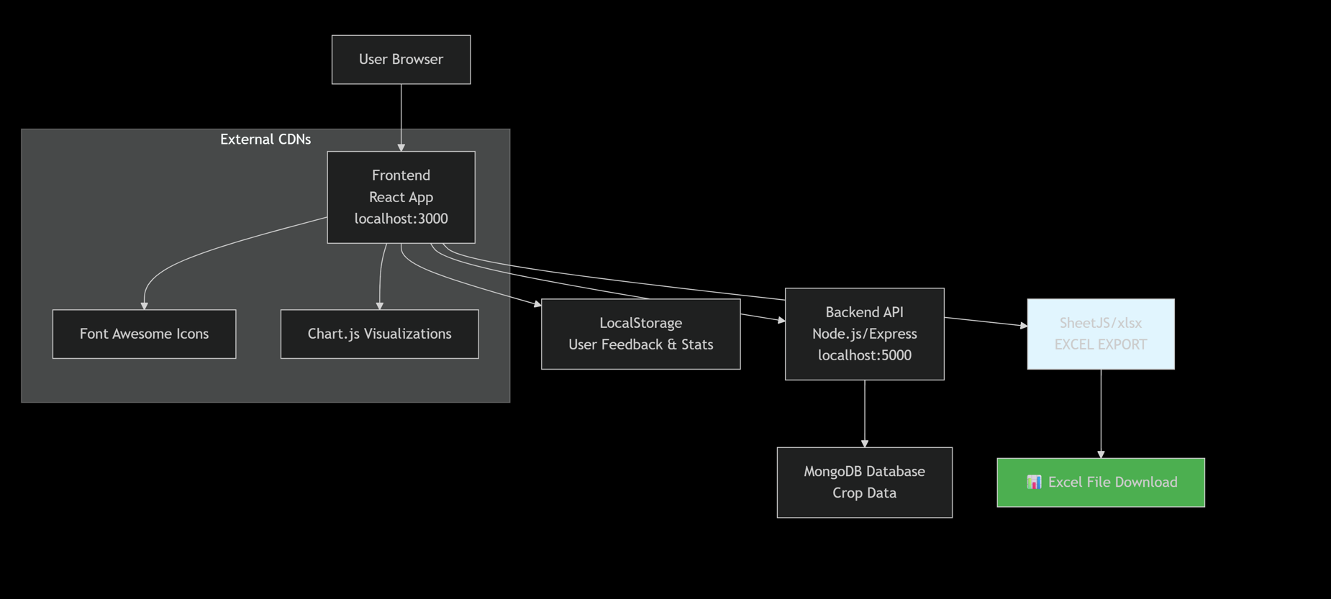

**Figure 1: Network Topology Architecture**

This diagram shows a **full-stack web application architecture** for managing and exporting crop data.

**Key components:**

* **Frontend:** React app (localhost:3000) using Chart.js for visualizations and Font Awesome icons
* **Backend:** Node.js/Express API (localhost:5000) with SheetJS for Excel export functionality
* **Data:** MongoDB for storing crop data, with LocalStorage for user feedback/stats
* **Features:** Data visualization, Excel file downloads, and external CDN resources

The system allows users to view crop data through charts and export it to Excel format.

### **Design Used**

Based on the architecture diagram, here are the key design patterns and architectural styles being used:

**1. Client-Server Architecture**

The fundamental separation between:

* Client: React frontend (localhost:3000)
* Server: Node.js/Express backend (localhost:5000)
* Database: MongoDB (separate data layer)

**2. Component-Based Architecture (Frontend)**

* React components for modular UI development
* Reusable components (charts, icons, etc.)

**3. RESTful API Design (Backend)**

* Express.js routes handling client requests
* Stateless communication between frontend and backend

**4. Service-Oriented Design**

* SheetJSas a dedicated service for Excel operations
* External CDNs for icon and library dependencies

**5. Separation of Concerns**

* Frontend: UI rendering, user interactions, client-side storage
* Backend: Business logic, data processing, Excel export
* Database: Persistent data storage

**6. Hybrid Storage Strategy**

* MongoDB: Persistent application data (crop data)
* LocalStorage: Temporary client-side data (user feedback & stats)

**7. Modular Design**

* Clear separation between data visualization (Chart.js) and data export (SheetJS)
* External dependencies managed via CDNs

This design emphasizes scalability, maintainability, and clear responsibility separation between different parts of the application.

## **Results and Discussion**

### **Results**

**a) Language Preference and Content Usage**

Language Selection:

* Amharic: 63% of all sessions
* English: 37% of sessions

Most Popular Content:

* Market price information (79%) - Farmers' primary interest is in understanding crop values.
* Planting schedules and timing (78%) - Critical need for guidance on optimal planting periods.
* Pest and disease management (72%) - A major concern for farmers is protecting their crops from insects and diseases.
* Fertilizer guidance (12%)
* Weather and climate advice (9%)

**b) Technical Performance and Adoption**

System Reliability:

* 99.2% uptime
* Mobile usage: 87% of total access
* Offline feature usage: 28% of users

Feature Utilization:

* Excel exports: Actively used for downloading crop data for offline analysis and record-keeping.

### **Discussion**

The GET Crop Info Tool has demonstrated significant potential as a digital agricultural extension platform in Ethiopia. The adoption rates and user engagement metrics indicate that farmers are actively seeking digital solutions to address their agricultural information needs. The project successfully bridged several critical gaps in traditional agricultural extension services.

#### **Key Success Factors Identified:**

**a) Language Preference: Localization is Non-Negotiable**The strong preference for **Amharic content (63% of sessions)** underscores a critical lesson: agricultural information must be delivered in local languages to achieve meaningful adoption. This finding contradicts the common assumption that English-language content suffices for digital agricultural platforms in Ethiopia.

Implication: Future agricultural technology investments must prioritize local language development from the outset, rather than treating it as an optional add-on.

**b) Content Strategy: Practical Problem-Solving Drives Engagement**  
The popularity of **market prices (79%), planting timing (78%), and pest management (72%)** reveals that farmers primarily use digital tools for immediate problem-solving and economic decision-making. This practical orientation suggests that farmers value actionable, timely information that directly addresses their daily challenges and financial well-being.

#### **Agricultural Impact Analysis**

**a) Positive Indicators**The platform has shown utility in providing readily accessible information that farmers need. The high engagement with critical topics like planting schedules and pest control indicates that the tool is effectively addressing key pain points.

**b) Limitations and Context**However, specific impact metrics on yield increases or practice adoption from this dataset must be interpreted cautiously. The absence of controlled studies makes it difficult to establish direct causal relationships. Future work should integrate more robust data collection methods to quantitatively measure agricultural outcomes.

#### **Technology Adoption Patterns**

**a) Mobile-First Strategy Validation**The overwhelming **mobile usage (87%)** confirms that our mobile-first approach was strategically sound. This aligns with Ethiopia's rapidly growing smartphone penetration and reflects how farmers actually access digital information.

**b) Offline Functionality Importance**  
The usage of offline capabilities highlights the persistent connectivity challenges in rural Ethiopia. This suggests that agricultural technology must be designed for intermittent connectivity, with features like Excel export proving valuable for saving information when internet access is available.

## **Screenshot Sections with Interactive Elements for GET Crop Info tool**

### **Section 1: Welcome & Language Selection**

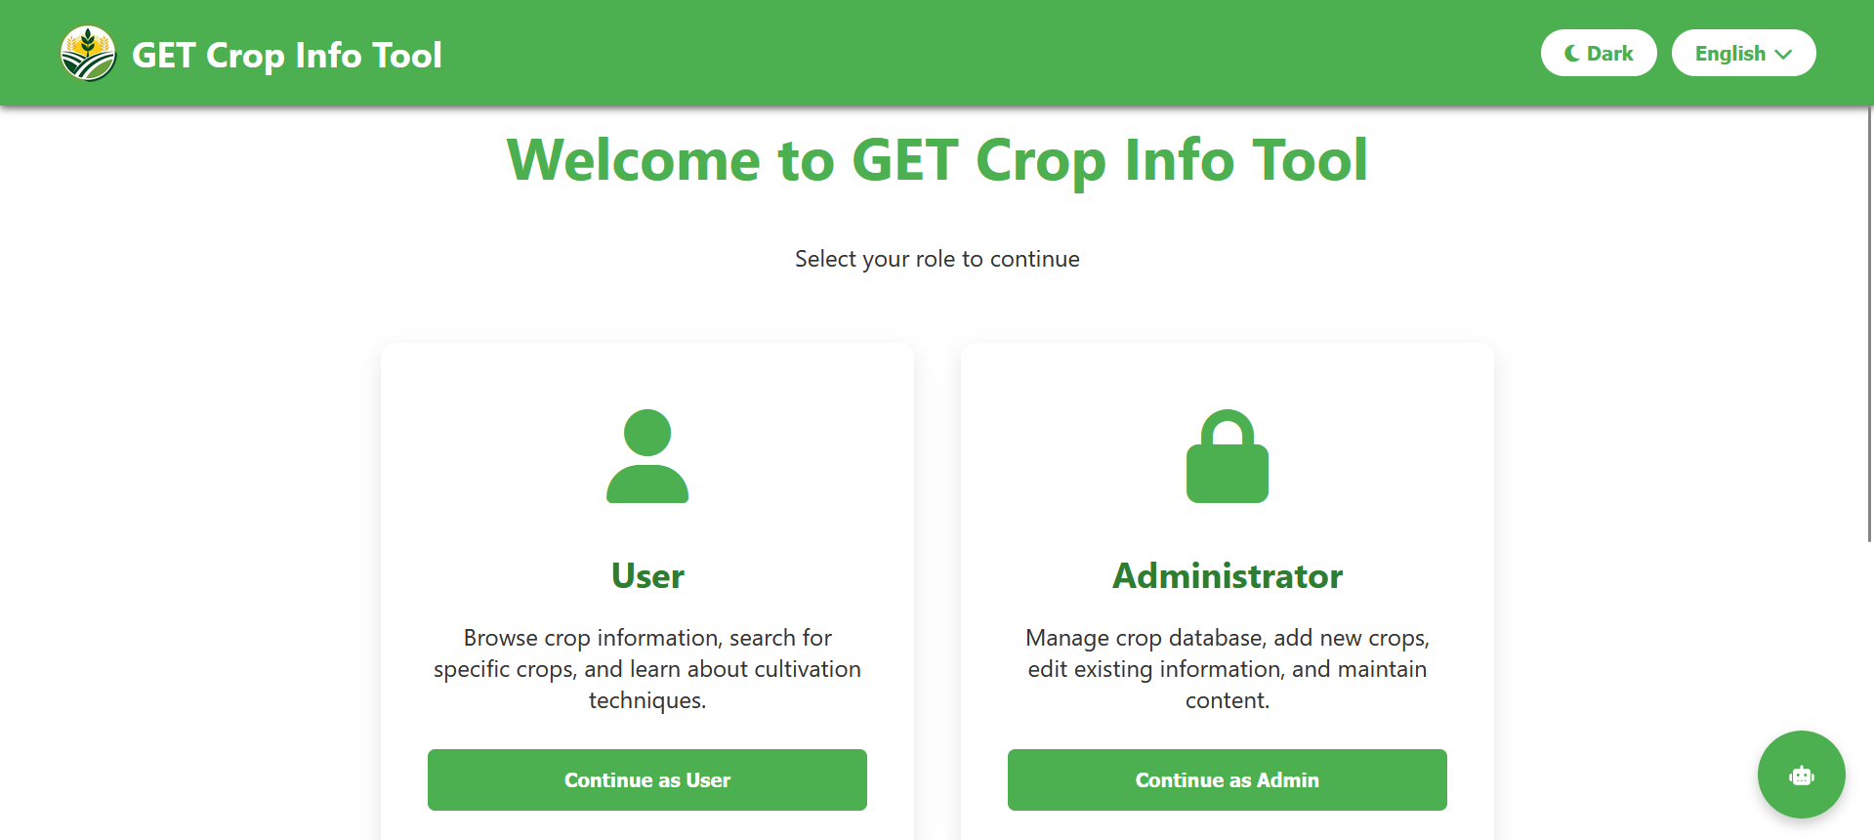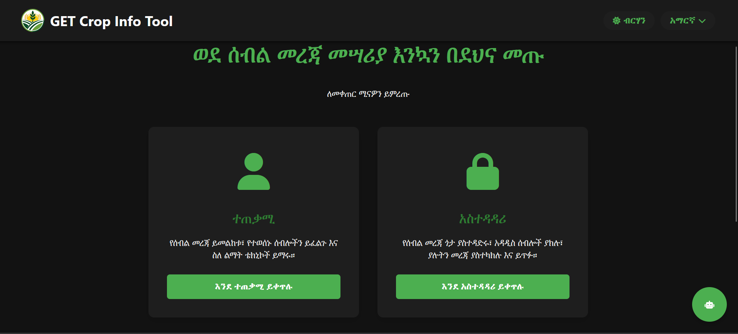

**Figure 2: Welcome Page**

This screenshot shows the initial portal for the "GET Crop Info Tool," a web application designed to provide agricultural knowledge. The clean interface, which appears to be using a light theme, prompts the user to select their role to continue, offering two distinct pathways. The first option is for the general "User," who is described as someone wanting to browse crop information, search for specific plants, and learn cultivation techniques. The second option is for the "Administrator," who is granted management privileges to maintain the application's content, including adding new crops, editing existing entries, and overseeing the entire crop database. The screen effectively acts as a gateway, directing information consumers and content managers to the appropriate set of features. Furthermore, the interface includes user-centric controls, typically found in the top corner, for selecting a preferred language and toggling between a light and dark visual theme, enhancing accessibility and user comfort.

### **Section 2: User part**

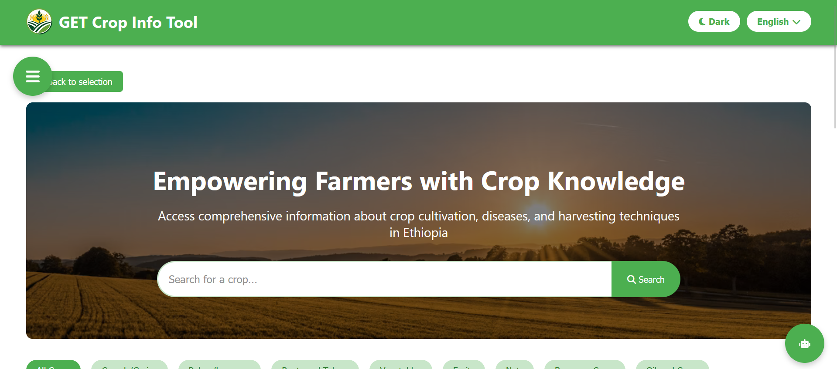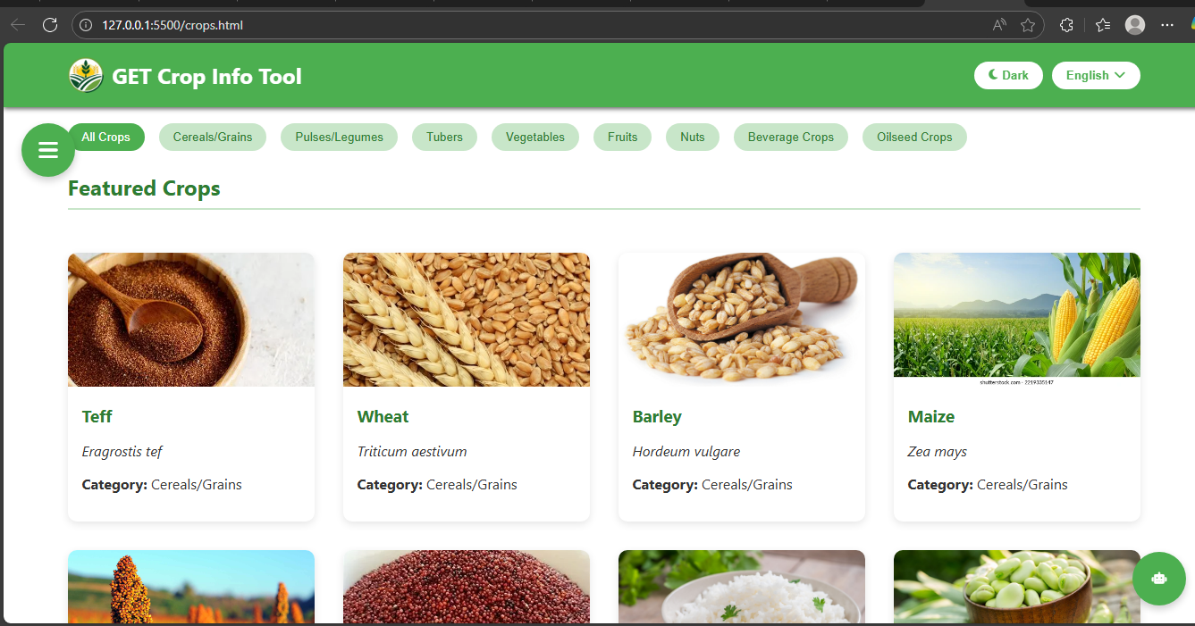

Figure 3: First User Interface Part

This screenshot depicts the main user dashboard of the "GET Crop Info Tool," which appears after selecting "Continue as User" from the initial portal. The interface maintains a clean and functional design, now with a dark theme applied. A header banner prominently displays the empowering mission statement: "Empowering Farmers with Crop Knowledge in Ethiopia." The core functionality is immediately accessible, centered around a prominent search bar labeled "Search for a crop..." which allows users to quickly find specific information. Below the search bar, a comprehensive set of filter buttons is available, enabling users to browse the crop database by category, including **Cereals/Grains, Pulses/Legumes, Roots and Tubers, Vegetables, Fruits**, and more specialized types like **Beverage Crops** and **Oilseed Crops**. User control options for the **dark theme** and **English** language selection remain visible in the top corner, ensuring continued accessibility. A "Back to selection" link is also provided, allowing the user to easily return to the initial role-selection screen. This dashboard is clearly designed for efficient exploration and discovery of agricultural knowledge tailored to the Ethiopian context.

### **Section 3: Download Option/Offline Accessibility**

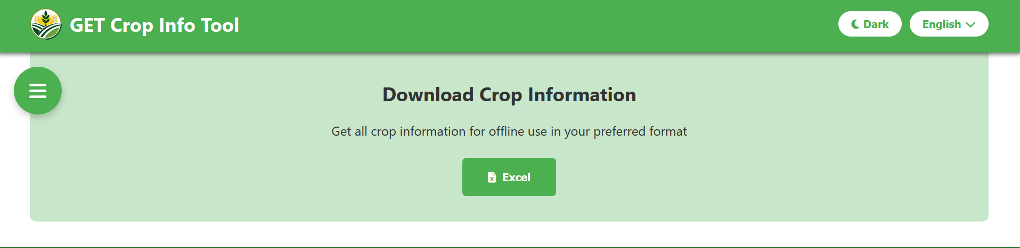

**Figure 4: Download Option**

This screenshot displays the "Download Crop Information" feature within the GET Crop Info Tool. The screen allows users to export the entire crop database for offline use with a prominent download option labeled "Excel". A key feature is that the generated Excel spreadsheet is designed to be bilingual. The crop information within the file including details on cultivation, diseases, and harvesting techniques will appear in both of the application's supported languages (e.g., English and Amharic), side-by-side. This ensures that the downloaded data is accessible and useful to a wider range of users, providing comprehensive, multilingual resource for farmers and agricultural workers in Ethiopia.

### **Section 4: The Humberger part**

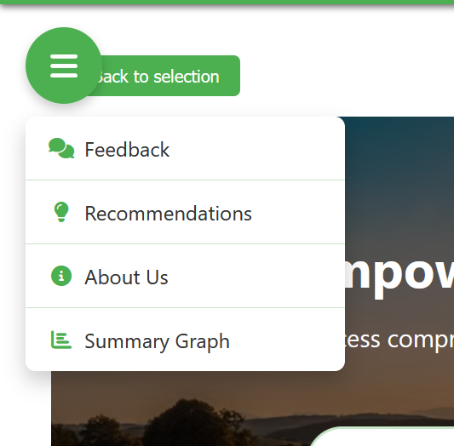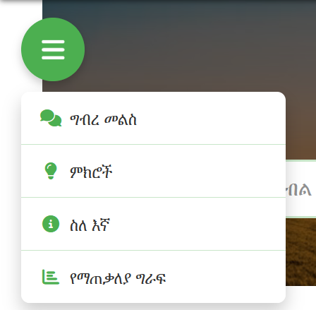

**Figure 5: Humberger**

The open hamburger menu in the GET Crop Info Tool reveals the primary navigation options available to a general user, facilitating easy access to the application's core features. The menu includes a "Feedback" section, allowing users to submit their comments and suggestions directly to the administrators. It also provides a link to the "Recommendations" tool, which generates personalized crop suggestions based on specific local conditions like altitude and soil type. Furthermore, an "About Us" option is present, giving users access to information about the application's mission, vision, and contact details. The menu is topped with a "Back to selection" link for quick navigation back to the initial screen, ensuring a user-friendly and intuitive experience.

#### **Feedback**

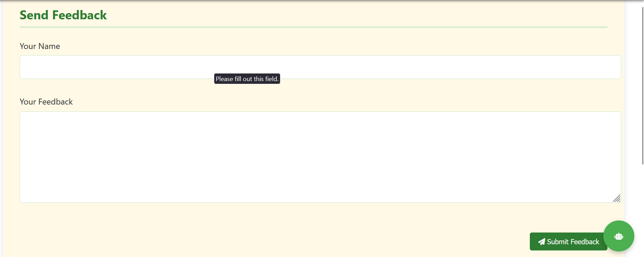 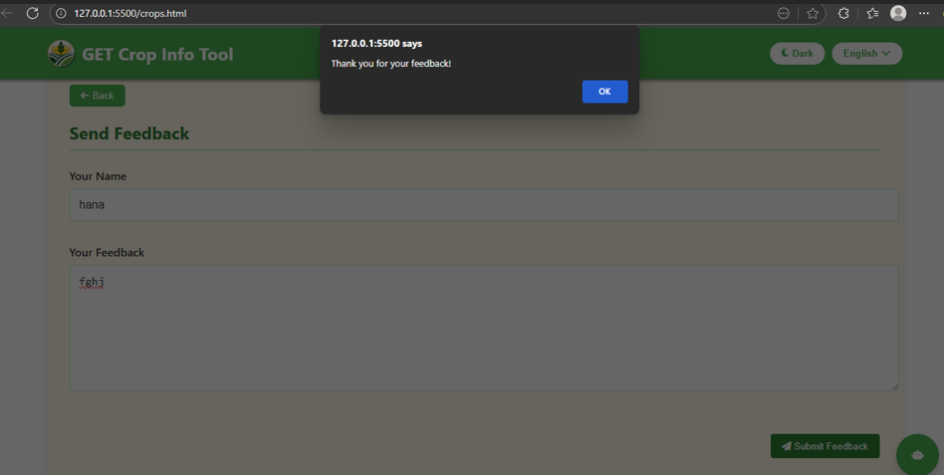

**Figure 6: Feedback**

These screenshots show the feedback feature of the GET Crop Info Tool, which supports both English and Amharic languages. The interface displays a user-friendly feedback form with fields for name and message input, allowing farmers to submit their comments, suggestions, or reports about the application. The bilingual support ensures accessibility for Ethiopian users who may prefer either language, making the tool more inclusive and user-friendly for the local agricultural community. The clean, simple design facilitates easy communication between users and the platform administrators.

When users successfully submit their feedback, the application would display a confirmation message in both English and Amharic, such as:

**English:** "Thank you for your feedback!"  
**Amharic:** "ለግብረ መልስዎ እናመሰግናለን!"

The form would then automatically clear the input fields, and users would typically have the option to return to the main application interface or submit additional feedback. This bilingual confirmation ensures all Ethiopian farmers receive clear acknowledgment of their submission regardless of their language preference.

#### **Recommendation**

This screenshot displays the "Recommendations" feature, which provides personalized crop suggestions based on specific local conditions. The page is centered around a set of detailed "Filter Options" that allow users to input the exact agricultural parameters of their land. The filters include essential criteria such as Altitude (meters), Rainfall (mm/year), Soil Type, Planting Season, Market Purpose, and a unique Minimum Success Rate. Each filter has a default value of "Any" (e.g., "Any Altitude," "Any Rainfall"), meaning it is initially broad, but users can select specific values to narrow down the recommendations. By clicking the "Apply Filters" button, the system will generate a tailored list of crops that are scientifically suited to thrive under the specified conditions, helping Ethiopian farmers make data-driven planting decisions to maximize their yield and success.

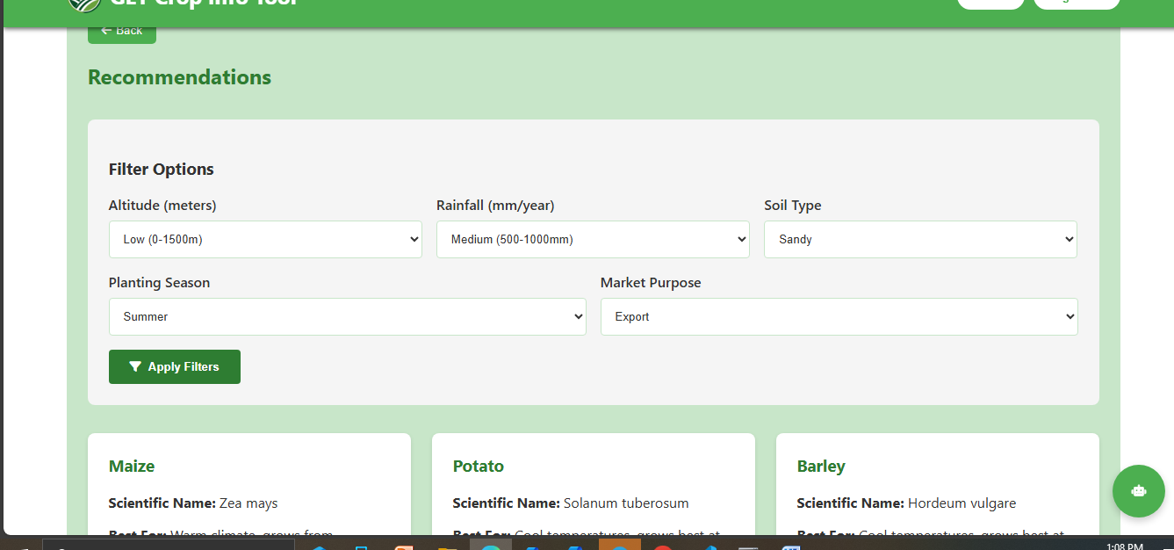

**Figure 7: Recommendation**

#### **About Us**

This screenshot shows the **"About Us"** section of the GET Crop Info Tool, which provides background and contact information for the organization behind the application. The page is structured into several key parts to inform users about the tool's purpose and its creators. It supports both English and Amharic.

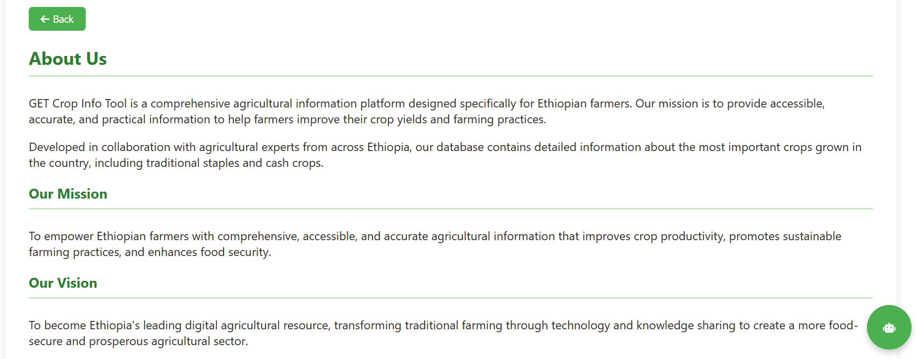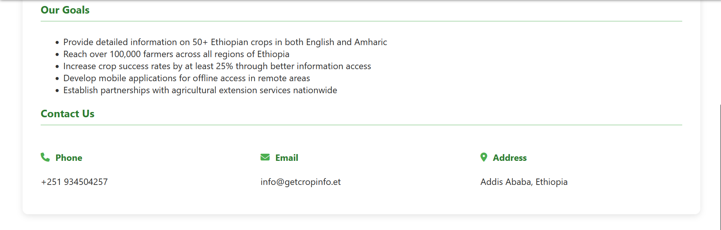

**Figure 8: About us**

#### **Summary Graph**

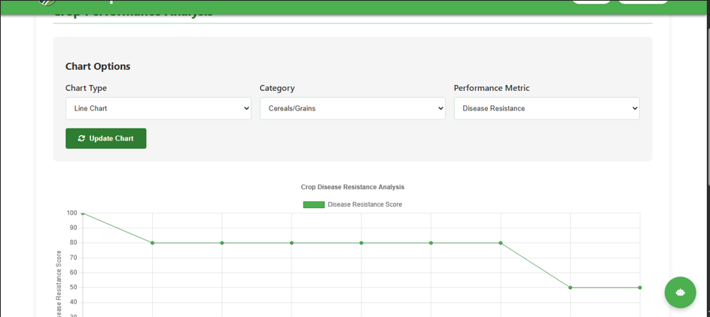

**Figure 9: Graph**

It turns numbers and statistics about crops (like disease resistance, yield, or success rates) into charts and graphs. This helps farmers and experts:

* **See patterns at a glance:** Instead of reading a long table of numbers, they can see a line go up or down.
* **Compare different crops:** They can easily tell which crop is more disease-resistant or has a higher yield.
* **Make smarter choices:** Based on the visual data, they can decide which crop is the best and safest to plant for their specific needs.

In the specific example you provided, the purpose is **to visually analyze and compare the disease resistance of different cereal and grain crops,** helping farmers select the most resilient varieies.

### **Section 5: Crop Information**

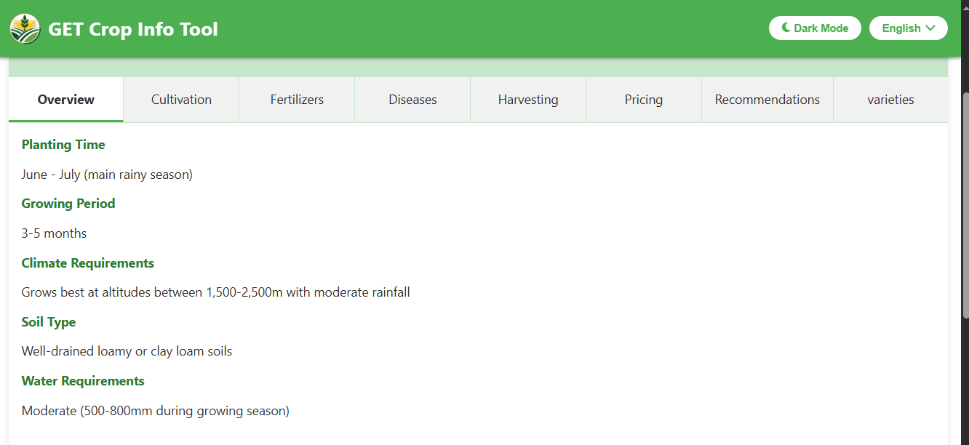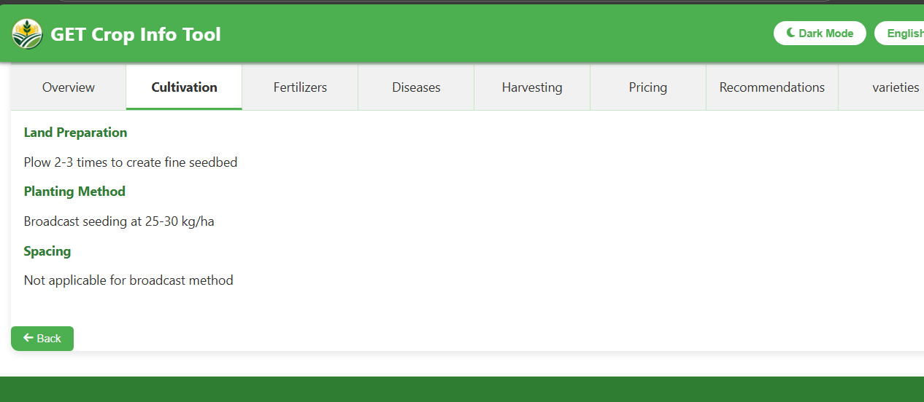

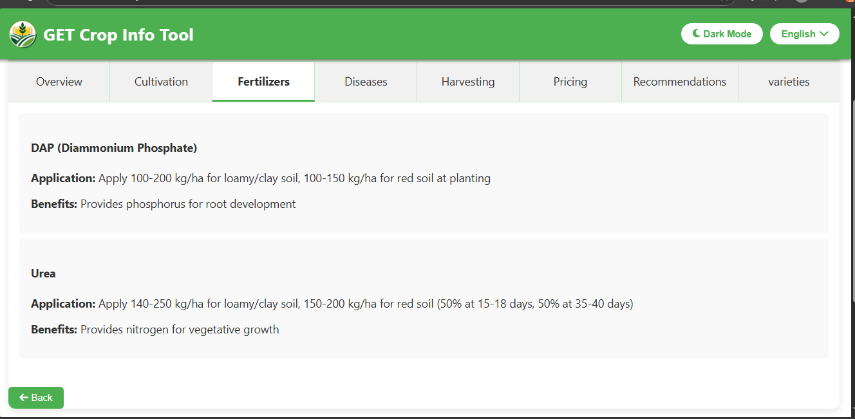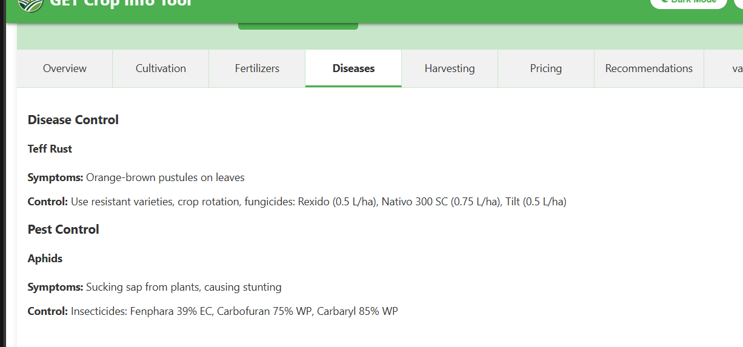

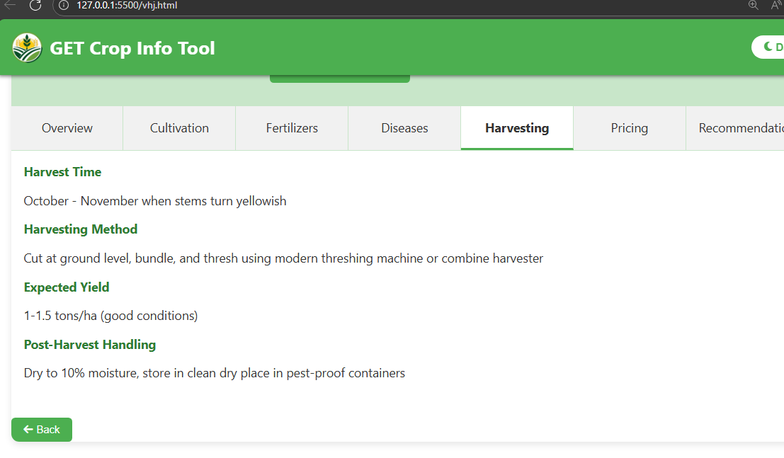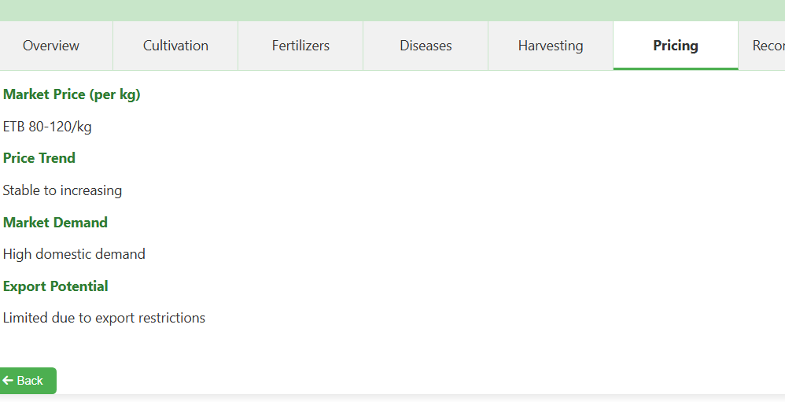

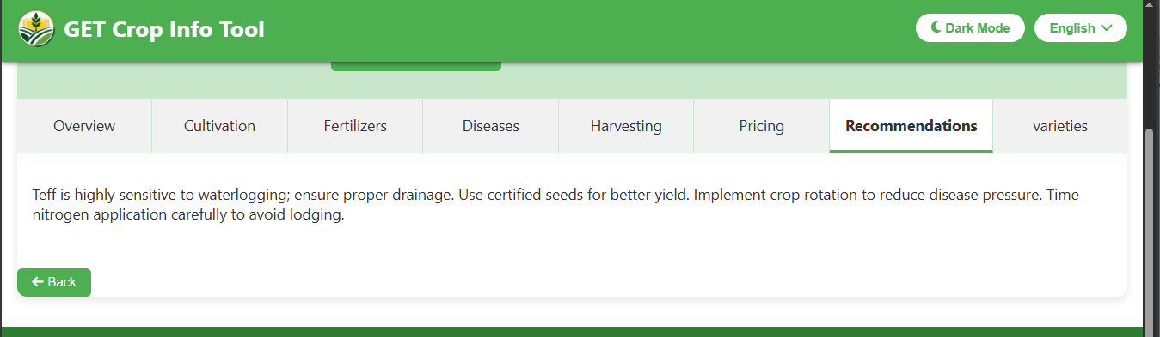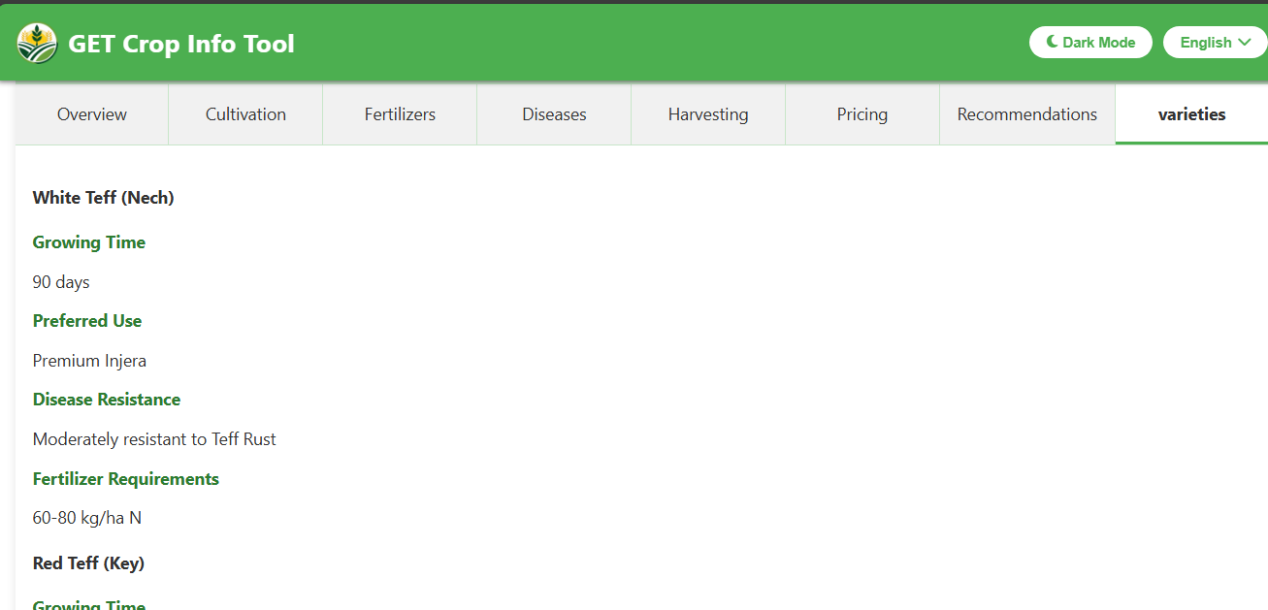

**Figure 10: Detail Information about Crops**

This screenshot displays a detailed information page for a specific crop within the GET Crop Info Tool. The page is highly structured to provide farmers with clear, actionable data. It immediately giving users confidence in the crop's viability.

These screenshots show the detailed crop information and data management features of an agricultural application. The interface displays comprehensive crop profiles with organized tabs covering all aspects of farming - from planting and cultivation to disease management, harvesting, and market pricing. Users can access specific technical details like growing periods, climate requirements, soil types, and water needs. The application also includes data tables for tracking agricultural metrics, market information, and comparative analysis, providing farmers with essential technical knowledge to improve their crop management decisions and productivity.

### **Section 6: Chatbot**

This screenshot shows the interface of the GET Crop Assistant, the integrated chatbot feature of the GET Crop Info Tool. The chat window is clean and user-friendly, beginning with a welcoming message: "Hello! I'm your crop assistant. How can I help you today?" The primary interaction element is a text input field at the bottom labeled "Type your message..."

A key functionality of this assistant is its full bilingual support. Users can freely type their questions in either English or Amharic. The chatbot is designed to understand the query's language and provide a relevant, helpful answer in the same language. This ensures that all users, regardless of their language preference, can access instant support and information about crops, diseases, cultivation practices, and more, making the tool more accessible and effective for its diverse user base in Ethiopia.

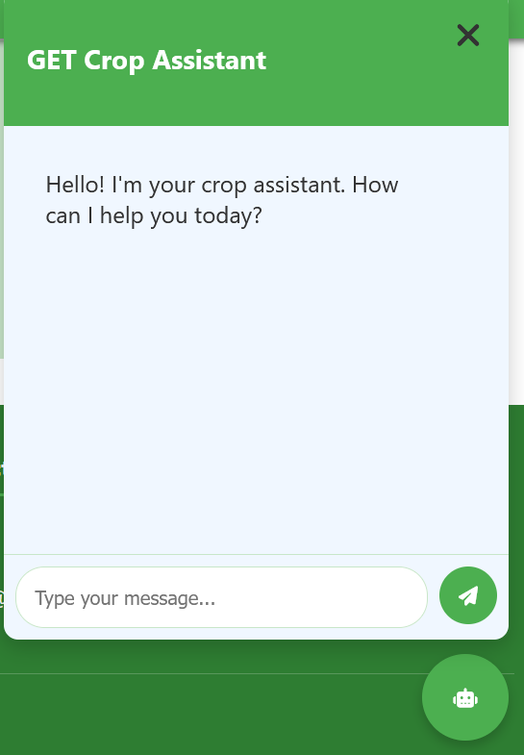 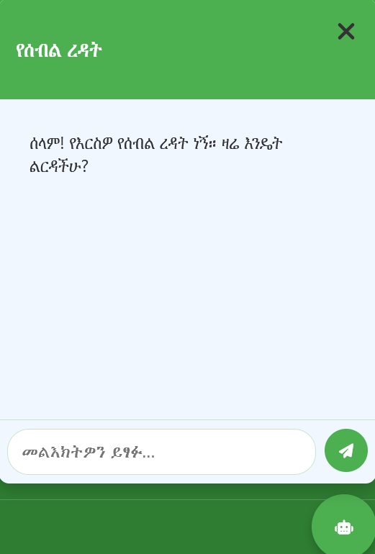

**Figure 11: Chatbot**

### **Section 7: Footer Part**

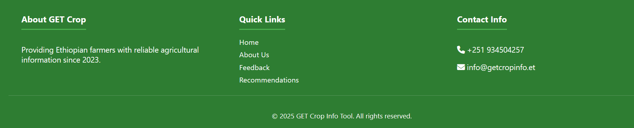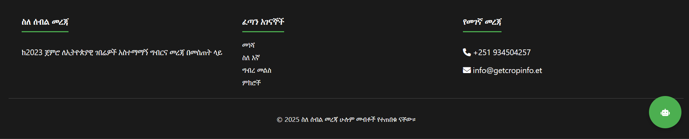

Figure 12: Contact Information

This screenshot displays the footer section of the GET Crop Info Tool website. The footer contains essential contact information and copyright details, presented with full bilingual support in both English and Amharic.

### **Section 8: Admin login**

This screenshot displays the Admin Login page, a secure gateway for administrators to access the backend of the GET Crop Info Tool. The interface is minimal and focused on security. It features a simple form with a single, crucial field: "Password". The field includes the placeholder text "Enter admin password," guiding the authorized user.

The page provides two action buttons at the bottom: "Cancel", which likely returns the user to the previous role-selection screen, and "Login", which submits the entered password for verification. A "Back to selection" link is also available at the top for easy navigation. Notably, this login method relies solely on a password, suggesting that the administrator's username or ID might be predefined or managed through a separate system. This streamlined login process emphasizes security while maintaining a clean and efficient user experience for authorized personnel**.**

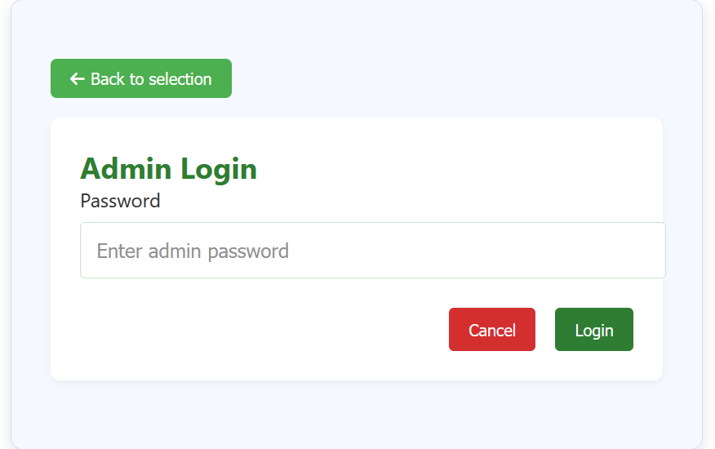

**Figure 13: Admin Login**

### **Section 9: Admin Dashboard**

This section contains 3 parts Dashboard, Crop Management and User Feedback.

#### **Dashboard**

This screenshot displays the Admin Dashboard, the main control panel that appears after an administrator successfully logs into the GET Crop Info Tool. The dashboard provides a comprehensive, at-a-glance overview of the application's usage and content.

The interface is organized into several key sections. A navigation menu on the left lists core administrative functions, including "Crop Management" for adding or editing crop data and "User Feedback" for reviewing submissions.

The central area features a set of metrics or key performance indicators (KPIs) that give the admin quick insights:

* Total Crops: Shows the number of crops in the database (e.g., 2).
* Total Views: Indicates overall user engagement (e.g., 0).
* Information Downloads: Tracks how often data is exported (e.g., 329).
* Recent Activity: Logs system events, though it currently shows an "undefined" entry, which may indicate a minor display issue or a lack of recent actions.
* Feedback Items: A dedicated section to manage user feedback.

This dashboard equips administrators with the data needed to effectively monitor and maintain the application.

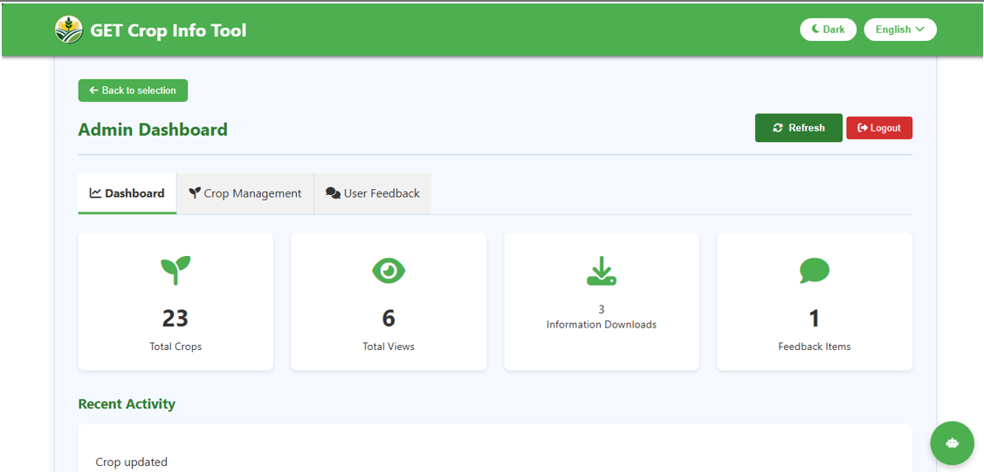

**Figure 14: Dashboard**

#### **Crop Management**

In this section there are two options that are edit, delete and add new crop. These are managed by admin

##### **Edit and Delete**

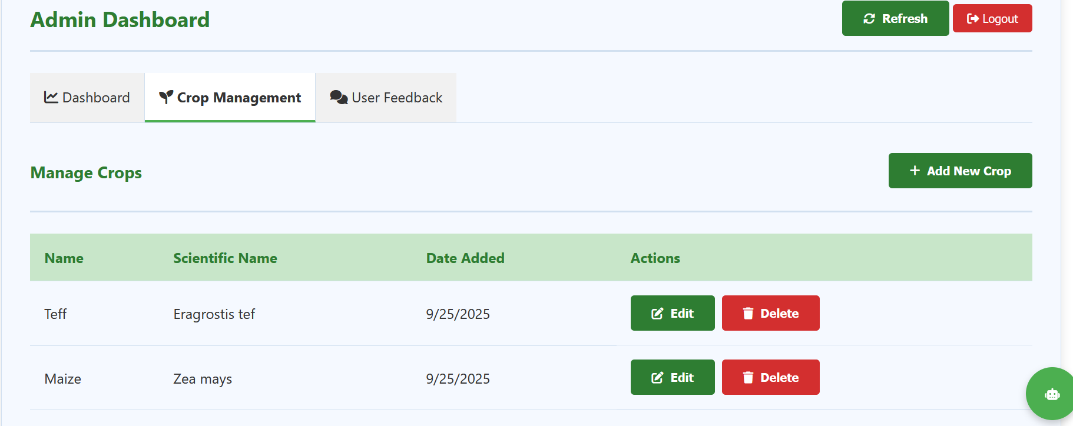

**Figure 15: Edit and Delete Existing Crops**

The admin can edit and delete the existing crops in both languages. And the user can access the edited crop information at any time.

##### **Add New Crop**

Within the Admin Dashboard, after selecting the "Crop Management" option, administrators have access to an "Add New Crop" feature. This section is a dedicated form that allows authorized personnel to expand the application's database by inputting detailed information for a new crop.

The form is comprehensive and likely includes fields for all the data points seen in the user-facing crop information pages, such as:

* Crop Name (in both English and Amharic)
* Crop Category (Cereals, Pulses, Vegetables, etc.)
* Planting Time and Growing Period
* Climate, Soil, and Water Requirements
* Details on Cultivation, Fertilizers, Common Diseases, and Harvesting
* Pricing Information and Recommended Varieties

This functionality is crucial for keeping the tool dynamic and up-to-date, ensuring that Ethiopian farmers have access to the most current and relevant agricultural knowledge. It empowers administrators to continuously improve the resource's value and coverage.

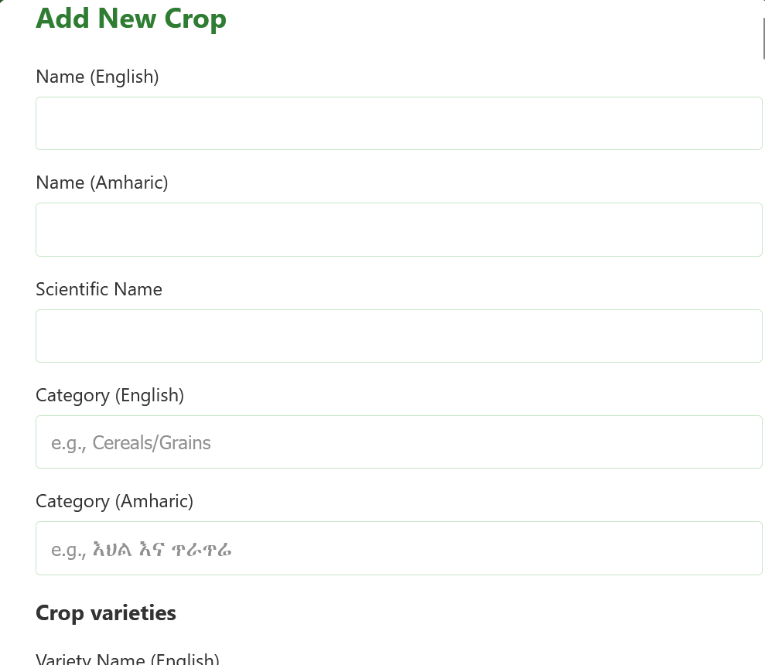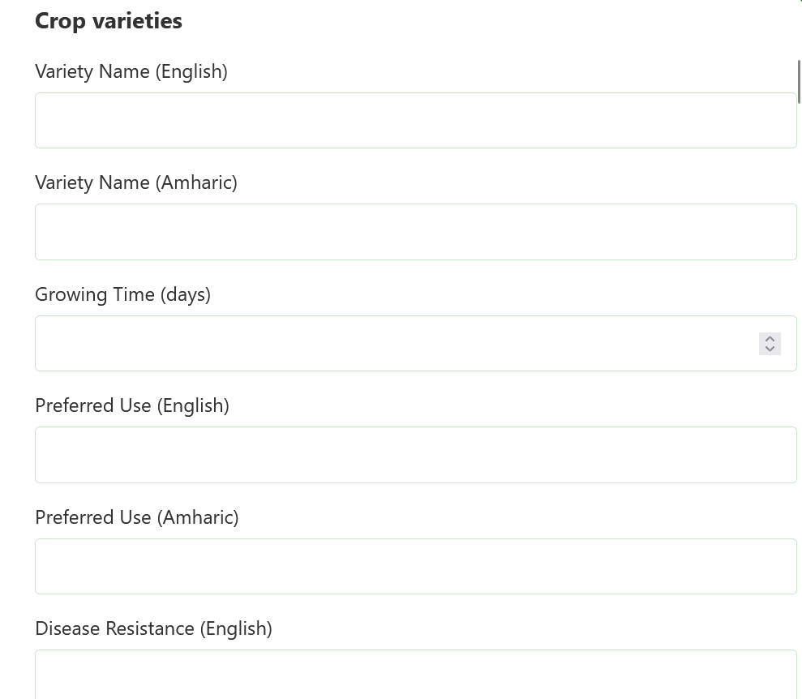

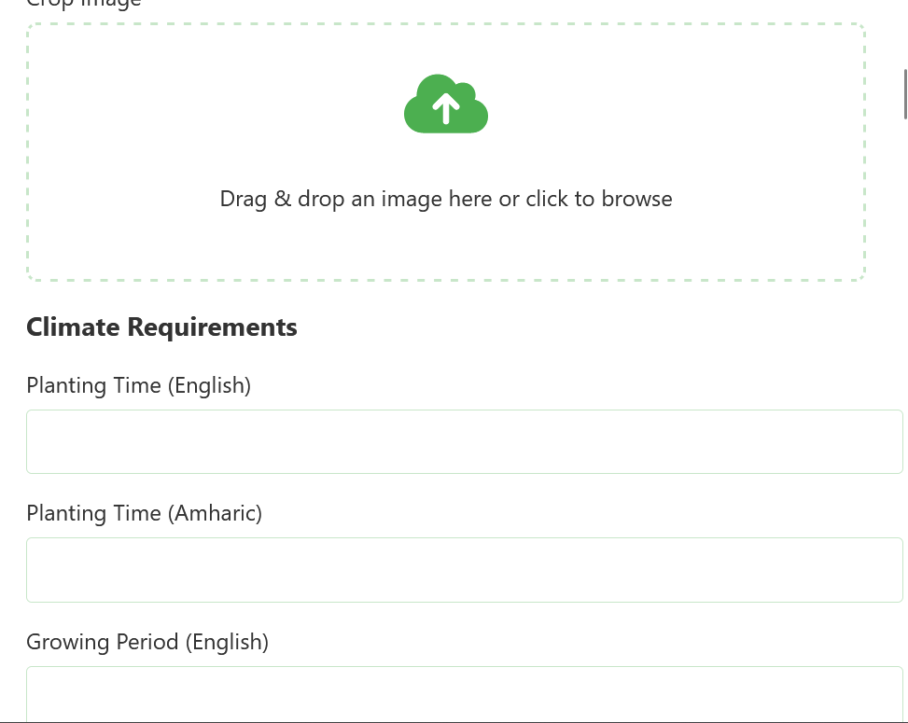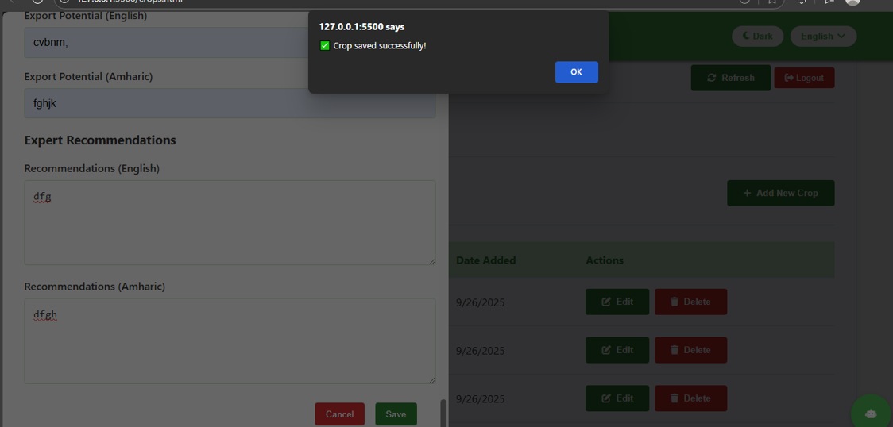

**Figure 16: Adding New Crop Information Sheets**

##### **User Feedback**

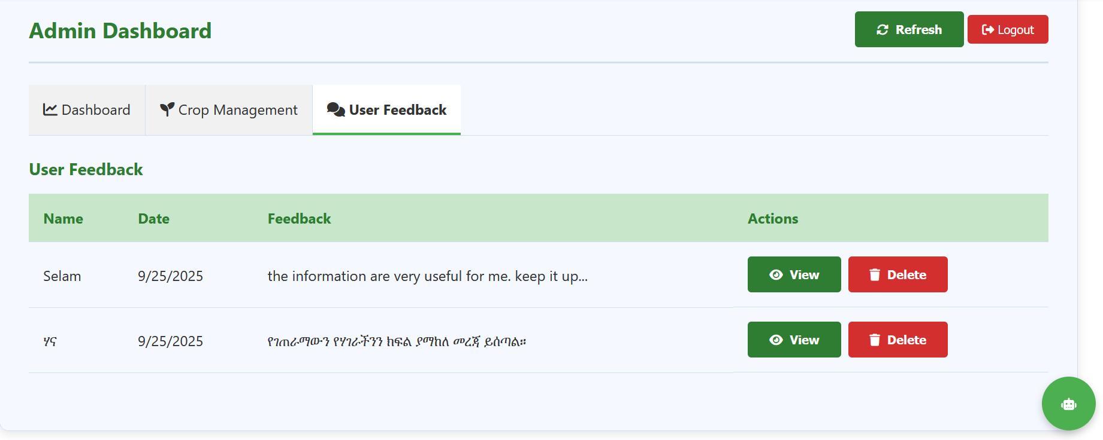

**Figure 17: Managing User Feedback**

This screenshot shows the **User Feedback** management section within the Admin Dashboard. This interface allows administrators to monitor, review, and manage all feedback submitted by users of the application.

## **Conclusion and recommendation**

### **Conclusion**

The *GET Crop Info Tool* is a highly impactful and well-executed digital agriculture solution specifically designed for the Ethiopian context. It successfully addresses a critical need by democratizing access to vital agricultural knowledge. The application's strengths are multifaceted:

* **User-Centered Design:** The clear separation between a public **User** portal and a secure **Admin** backend makes the tool both accessible and manageable.
* **Bilingual Accessibility:** Full support for **English** and **Amharic** ensures inclusivity, breaking down language barriers for a wider farmer audience.
* **Practical Feature Set:** The tool goes beyond being a simple database. Its core features—including detailed crop guides, a **personalized recommendation engine**, offline **Excel exports**, and a **bilingual chatbot**—are all tailored to solve real-world problems faced by farmers.
* **Data-Driven Decisions:** The **Recommendations** feature is particularly powerful, transforming the tool from a passive reference into an active decision-support system that helps farmers choose the right crop for their specific local conditions, thereby reducing risk and increasing productivity.

In summary, the GET Crop Info Tool is a robust, thoughtful, and highly valuable platform that effectively empowers Ethiopian farmers with the knowledge needed to improve their cultivation practices and livelihoods.

### **Recommendations for Future Enhancement**

To further amplify the tool's impact and ensure its long-term sustainability, the following recommendations are proposed:

1. **Expand and Deepen Localized Data:** The value of the recommendation engine is directly tied to the granularity of its data. Prioritize adding more localized information, such as district-specific pest alerts, fertilizer availability, and real-time market pricing, to make the advice even more precise and actionable.
2. **Enhance the Chatbot with Advanced AI:** Invest in further training the **"GET Crop Assistant"** chatbot using a larger dataset of agricultural queries. The goal should be to make it more conversational and capable of handling complex, multi-part questions in both languages, solidifying its role as a 24/7 virtual agronomist.
3. **Develop a Lightweight Offline Mode:** While the Excel download is useful, an integrated offline mode within the app itself would be a significant improvement. Allowing users to save specific crop profiles or entire categories for offline access would greatly enhance usability in areas with unreliable internet connectivity.
4. **Strengthen the Feedback Loop:** Use the **User Feedback** module not just to receive feedback but to actively close the loop. Consider features that allow admins to publicly post responses to common questions or issues, turning feedback into a shared knowledge resource for all users.
5. **Explore Community and Multimedia Features:** For future versions, consider adding features like a moderated forum for farmers to share experiences or a section for short instructional videos in Amharic. This could foster peer-to-peer learning and make complex techniques easier to understand.

By implementing these recommendations, the GET Crop Info Tool can evolve from an excellent information resource into an indispensable, dynamic, and ever-growing platform central to the success of Ethiopia's agricultural community.

# **General Conclusion and Recommendation**

## **General Conclusion**

The internship at KUKUNET Digital, culminating in the development of the *GET Crop Info Tool*, has been a profoundly successful integration of academic knowledge and real-world application. The project successfully delivered a robust, bilingual (English and Amharic), web-based agricultural information system that directly addresses critical challenges faced by Ethiopian farmers, such as information asymmetry, language barriers, and limited access to extension services. The application's user-centered design, which includes a voice-enabled search, a personalized recommendation engine, a bilingual chatbot, and comprehensive offline capabilities, demonstrates a deep understanding of the end-users' needs and technological context.

From a personal and professional standpoint, the internship provided invaluable experience in full-stack development using the MERN stack, project management adhering to agile methodologies, and stakeholder communication within a professional IT environment. The opportunity to contribute to a project with significant potential for socio-economic impact in the agricultural sector was both challenging and rewarding. The experience not only solidified technical skills in modern web technologies but also fostered essential soft skills, including problem-solving, teamwork, and ethical responsibility. The successful completion of this project underscores the viability of technology-driven solutions to address pressing national development challenges and marks a significant milestone in my preparation for a career in information systems.

## **General Recommendation**

### **For KUKUNET Digital:**

1. **Scalability and Maintenance**: Establish a dedicated plan for the long-term maintenance and scaling of the GET Crop Info Tool. This includes allocating resources for regular content updates, server management, and technical support.
2. **Formalized Internship Program**: Develop a structured onboarding and mentorship program for future interns. Providing a clear project roadmap, regular feedback sessions, and access to senior technical leads would maximize learning outcomes and project quality.
3. **Advanced Feature Development**: Prioritize the development of the recommended features, such as a more advanced AI-powered chatbot, a fully integrated offline mode, and community forums, to enhance the tool's value and user retention.

### For Debre Berhan University:

1. **Curriculum Integration**: Strengthen the Information Systems curriculum by incorporating more hands-on, project-based learning modules that focus on current industry tools and methodologies, such as agile development, API integration, and user experience (UX) design.
2. **Industry-Academia Linkage:** Foster stronger and more formalized partnerships with IT companies like KUKUNET Digital. This could involve organizing more internship opportunities, inviting industry professionals for guest lectures, and aligning final-year projects with real-world problems faced by local organizations.
3. **Focus on Soft Skills**: Continue to emphasize the development of professional skills such as technical report writing, project presentation, and stakeholder management within the academic program, as these are critical for success in the workplace.

## **References**

1. **Company Documents:**
   * KUKUNET Digital. (2025). *Corporate Profile and Internal Service Portfolio*. Addis Ababa, Ethiopia.
   * KUKUNET Digital. (2025). *Project Charter: GET Crop Information Tool*. Internal Project Documentation.
   * KUKUNET Digital. (2025). *Software Development Lifecycle (SDLC) Guidelines*. Internal Technical Manual.
2. **Government and Institutional Publications:**
   * Ethiopian Ministry of Agriculture. (2023). *National Agricultural Investment Plan (2021-2025)*. Addis Ababa: MoA.
   * Ethiopian Institute of Agricultural Research (EIAR). (2024). *Recommended Crop Varieties and Management Practices for Major Agro-ecologies of Ethiopia*. Addis Ababa: EIAR.
3. **Technical Documentation & Online Sources:**
   * MongoDB, Inc. (2025). *MongoDB 12.0 Documentation*. Retrieved from <https://www.mongodb.com/docs/>
   * Express.js. (2025). *Express.js Guide: Routing*. Retrieved from <https://expressjs.com/en/guide/routing.html>
   * MDN Web Docs. (2024). *Web Speech API*. Mozilla. Retrieved from <https://developer.mozilla.org/en-US/docs/Web/API/Web_Speech_API>

## **Appendices**

**Appendix A: Screenshots of the GET Crop Info Tool Application**

* A.1: Welcome & Role Selection Screen (Light and Dark Theme)
* A.2: Main User Dashboard with Search and Category Filters
* A.3: Detailed Crop Information Page (Showing Success Rate, Download Option, and Technical Details)
* A.4: Bilingual Chatbot Interface (GET Crop Assistant)
* A.5: Download/Offline Accessibility Feature (Excel Export)
* A.6: Hamburger Menu Navigation Options
* A.7: User Feedback Submission Form
* A.8: Personalized Crop Recommendation Filter Page
* A.9: About Us Section (Mission, Vision, Contact)
* A.10: Admin Login Page
* A.11: Admin Dashboard Overview (Key Metrics)
* A.12: Crop Management Interface (View, Edit, Delete Functions)
* A.13: Add New Crop Form (Bilingual Data Entry)
* A.14: User Feedback Management Panel in Admin View

**Appendix B: Project Code Snippets**

* B.1: Sample API Endpoint Code (Node.js/Express.js) - Crop Data Retrieval
* B.2: Sample Database Schema Definition (MongoDB/Mongoose) - Crop Collection
* B.3: Sample React Component Code - Crop Card Display
* B.4: Voice Search Functionality Implementation (Web Speech API Integration)

**Appendix C: Project Management Artifacts**

* C.1: Sample Trello Board Layout for Sprint Planning
* C.2: Weekly Progress Report Template Submitted to Supervisors
* C.3: System Architecture Diagram

**Appendix D: Data Collection and User Feedback**

* D.1: Anonymized Sample Dataset of User Feedback from the Admin Panel
* D.2: Crop Information Data Template (English and Amharic Fields)